BSc (Hons) Computer Networks (TopUp)

(Batch 006 – February 2020)

Project and Professionalism

6CS007/CN3

Final Project Report

Integrated Solution for Smart Parking Management System

By K.M.D Upul Ishantha Jayathilaka (UoW ID: 2018404)

Module Leader: Mr. Thilak De Silva

Project Supervisor: Mr. Dhishan Dhemmearatchi

Project Reeder: Mr. Rajeew Perera

Submission Date: 10th of January 2020

# Declaration

I do firmly declare that this work or any part of thereof, has not been previously presented in any university or any other educational institute whether as a project or any other purposes. I strongly confirm that the content of this project is my own effort, the work reported in this project was exclusively carried out by me under the supervision of Mr. Dhishan Dhemmearatchi. It describes the result of my own independent research expect where due reference has been made in the text. No part of this project has been submitted earlier or concurrently for the same or any other degree.

Date: …10/01/2021……… ………………………………………

Signature of Candidate

I endorse the declaration by the candidate.

…………………………………………..

Mr. Dhishan Dhemmearatchi

(Supervisor)

Date: …………………………….

# Abstract

The increase the number of vehicles from past few decades there is need of to fulfill its requirements, on roads it leads to more traffic congestions, more accidents, people had to face not having enough parking spaces for increasing number of vehicles . It had been introduced new rules and regulations, expands roads, build new systems to prevent uncomfortable situations because of increasing high number of vehicles. People have made attention to improve parking problems people face, safety of people also the safety of vehicles, high time consumption, less user-friendliness people tried to improve traditional parking system people had been using, the solution came as the smart parking. In this project the tutor has tried to develop a system which give user more useful features that will help users to use parking properly. The tutor has decided to use a QR code for authenticate users in the parking. It has decided to use because QR is more user friendly and works quickly . The tutor has introduced a web-based application for users to interact with parking, which has included online booking, online registration, check availability of parking and online bill payments. The system has introduced security warming system which notify user in case of emergency. The tutor has given solution for issues related to traditional parking system

# Acknowledgement

I take this opportunity to thank my lecturer Mr. Thilak De Silva, my friends and my parents who supported me to make this project successful. I gradually acknowledge my deep indebtedness to all these people.

With the deep sense of gratitude, I acknowledge the engorgement and the guidance received by my project supervisor Mr. Dhishan Dhemmearatchi who helped and supported me during the project. I would like to thank him for that.

Finally, I would like to thank for all the people who helped me with this project.

**Contents**

Declaration 2

Abstract 3

Acknowledgement 4

List of Figures 7

List of Tables 10

Chapter 01 – Introduction 11

1.1 Background 11

1.2 Aims of the Project 12

1.3 Academic Questions and Objective 13

1.3.1 Academic Questions 13

1.3.2 Objectives 13

1.4 Scope 13

1.5 Structure of the Report 20

Chapter 02 – Literature Review 23

2.1 Introduction 23

2.2 Similar Projects 24

Chapter 03 – Methodology 25

3.1 Planning 26

3.1.1 Identifying Business Values 27

3.1.2 Feasibility Analysis 27

3.1.3 Work Plan 30

3.2 Analysis and Requirement Gathering 31

3.2.1 Analysis 31

3.2.2 Requirement Gathering 31

3.3 Designing 35

3.3.1 Physical Design 35

3.3.2 Architecture Design 39

3.3.3 Interface Design 40

3.4 Implementation 54

3.5 Testing 60

3.5.1 Unit Testing 60

3.5.2 Integration Testing 63

3.5.3 System Testing 64

Chapter 04 – Artifact 67

4.1 Academic Findings 67

4.2 Sample Code 68

4.3 Test Cases 70

Chapter 05 – Conclusion 74

5.1Important Outcome 74

5.2 Limitation 74

5.3 Critical Evaluation 74

5.4 Future Work 75

References 75

# List of Figures

Figure 1: Prototype Model 25

Figure 2: Pie chart Need of smart parking solution 33

Figure 3: The increase in the number of passenger vehicles per 1000 inhabitants in EU (M Alam, 2018) 34

Figure 4: flow chart of parking system for registered users 35

Figure 5: flow chart of booking in the parking system 37

Figure 6: Architecture design of the parking system 39

Figure 7: Interface design of My Park Bot Application 40

Figure 8: User log in interface in web based mobile application 41

Figure 9: Crete user interface in mobile application 42

Figure 10: My Park Bot registration form 43

Figure 11: User dashboard on mobile application 44

Figure 12: Parking space design on mobile application 45

Figure 13: Booking log details table on mobile app 46

Figure 14: Smart wallet on mobile application 47

Figure 15: Administration dashboard in parkin system 48

Figure 16: Parking details table 48

Figure 17: QR scanner 49

Figure 18: Booking details log 49

Figure 19: Payment log sheet log 50

Figure 20: User Table 51

Figure 21: User Registration 51

Figure 22: QR scanner entrance and exit 51

Figure 23: QR scanner parking space 52

Figure 24: My SQL database 53

Figure 25: Interface design of Parking lot Management 53

Figure 26: Implementation design of the parking system 54

Figure 27: Parking slot design bread broad diagram using fritzing software 55

Figure 28: Schematic diagram of the parking slot using frizzing software 55

Figure 29: Entrance and exit design bread bored diagram using frizzing software 56

Figure 30: Entrance and exit design symmetric diagram using frizzing software 57

Figure 31: User warning system bred board diagram using fritzing software 58

Figure 32: User warning system symmetric diagram using fritzing software 59

Figure 33: Unit testing 1 verify ultrasonic sensor is working 60

Figure 34: Unit test 2 verify servo mother is working 61

Figure 35: Unit test 3 verify IR sensor is working 62

Figure 36: Integrating test 1 send data to MySQL database using ultrasonic sensor 63

Figure 37: System testing 1 authenticate user using entrance exit QR scanner 64

Figure 38: System testing 2 Authenticate users at the exit and smart wallet 65

Figure 39: System testing 3 administration dashboard check 66

Figure 40: Sample code 1 servo motors 68

Figure 41: Sample code 2 ultrasonic sensor 69

Figure 42: Test case 1 user side system dashboard check 70

Figure 43: Test case 3 check wrong password combination 71

Figure 44: Test case 3 user log out 72

Figure 45: Test case 4 QR authentication 73

# List of Tables

Table 1: Data gathering using questionnaires 32

# Chapter 01 – Introduction

## 1.1 Background

Today there’s a significant improvement in Automobile industry . It has been developing to fulfill human needs from the past, adding improvements with new technologies. Automobile companies are trying to give various opportunities to customers to fulfill their needs. Electric vehicles have become more popular today which is environment friendly. With increasing number of vehicles, there should be more space to manage it, should be proper parking solutions, otherwise it can lead to cause many problems in many ways to the people and for the society. Parking take much space in big cities and it is also bringing major income. A survey shows that averagely parking takes 31% of land use in big city like San Francisco, 81% in Los Angeles, 76% in Melbourne, New York 18%, London 16% and Tokyo 7%. (Manville Michael, 2006).

High parking coverage density constraint urban development in cities, remove unnecessary parking areas is 1st step for a better urban planning (Mikhail Chester, 2015). A proper urban planning can reduce the traffic in cities and here should be a smart parking solution to avoid taking too much land space in cities for parking. Most of developing countries and some developed countries still use traditional parking systems which is not appeals to today. Traditional system have major drawbacks. Nowadays most people use smart technologies, this has made people’s life easy and time saving, smart phone has become an essential device to fulfill their daily tasks.

In this project I have introduced solutions for overcome major issues involved in traditional parking systems using new technologies which is related to toady. I have developed this parking system to be more modern way to suit people’s life today. It’s a smart, automated parking system with minimum human involvement. It also has higher security and safe for people, also for the vehicles. The new system is more user-friendly and effective. There are many authenticate methods have used in parking systems to verify users which are password-based authentication, multi-factor authentication, certificate-based authentication, biometric authentication and token-based authentication. In here in my project I have used QR(Quick Response) code. It’s a two-dimensional barcode, this has introduced by a Japanese company called Denso-Wave in 1994. (18004, 2000). QR code contains the information in vertical and also horizontal direction. When compare a barcode with QR, barcode only include data in one direction and QR code can hold more information compare to a barcode, 7089 numeric, 4296 alphanumeric data, 2953 of binary. It has derived from “Quick Response”. (Kuan-Chieh Liao, 2010). It has super-fast reading capabilities (decoding) compare to any other authentication method that already has deployed in parking systems and it is more reliable compare to other methods. This QR code has used to operate gates automatically of the parking. I have developed a web based mobile application for users and for the administration, for users this make to use parking system more friendly way. Using parking app user can register to parking system online, the system generates a unique QR code for every registered user. Users also can see the availability of the parking slots in real time, online booking, online payments using smart vault. On other side of the system, administration side has developed to manage the parking system in a proper way. I have set up QR scanners here. Admin can add team members to the parking, also activate and deactivate user accounts, online booking and cancellation, parking details table, Booking details table, Parking details log, payment details log, Reset password of users, see the income of the parking, see the availability of parking slots and For increase the security of the parking I have set up the system to send warning notification for users in a case of emergency.

## 1.2 Aims of the Project

The aim of this project is to create a secured automated smart parking system with minimum human involvement.

## 1.3 Academic Questions and Objective

### 1.3.1 Academic Questions

How to reduce human involvement in a smart parking system and make it autonomous

How to make smart parking system more secured

How to prevent unauthorize access in a smart parking system

How to improve user-friendliness in smart parking system and increase user satisfaction

How to overcome challenges involved with autonomous parking system

### 1.3.2 Objectives

Develop a logical model for user authorization and for bill payments

Develop a web application for increase the user friendliness in the parking system

Develop a system using micro controllers and sensors

Develop a warning system to notify users in case of emergency

Implement the system and test the prototype created for smart parking system.

## 1.4 Scope

The title of the project is Integrated solution for smart parking management system and main aim is to create secured, automated parking system with minimum human involvement. The tutor has proposed a system to achieve requirements to project objectives and research questions. The research area of the project is to give smart parking solution for Central Business District (CBD) area of an urban city. Urban area of city has selected has project scope; it has narrowed down to that area. The traffic congestion is high in CBD areas it’s difficult to find a free parking space. People are cruising around the city searching free space, it also increases traffic and fuel. Introduced protype is a smart multistore is a private parking system which gives more space for vehicles without taking wide space form city area. There many people come to CBD from city suburbs for fulfill various needs, this mainly increasing traffic congestion of the city. The proposed system has introduced for give a solution for decrease the traffic and prevent vehicle accidents.

It has created a problematic situation today due to increasing number of vehicles. This has made Increasing road accidents, increasing traffic congestion on roads which waste of time and fuel, high environmental pollution, health issues because of toxic vehicle gasses, difficult to find free space for parking vehicles, street parking block roads and make accidents. Because of difficulties people have to face, it also has increase road violence called road range. This can affect people’s life and for the society in a bad way. People usually trying to reach their destinations as quickly as they can, people have to keep up with their busy daily working schedule. Here, in this my project I have tried to develop a system which can helpful for them to use parking easy way. I have suggested smart parking solution which helpful for users. This is an automatic system; For users it has made to use the parking system more friendly way. New system gives more advantage features for users compare to a manual traditional parking system. I’ve developed a web based mobile application, user can use this to interact with the parking they can register to parking online, see availability of parking in real time, online booking, online payments, the authentication process done by using a QR code which is fast and reliable. Gates of the parking work automatically for uses, New system has developed for users to save time and increase the user satisfaction.

The main goal/purpose of this project is to give solutions for people whose facing problematic situations when they use parking and increase user satisfaction. There are several sub goals of this project. New system can help to decrease road accidents on road which is happing because of in proper way of parking. People use side of street to park their vehicles this is called street parking. This can reduce the spaces of roads and cause accidents it also can leads to traffic congestion of the cities; pedestrians have face for difficulties when vehicle parked on pavements. Another goal of the project is removing unnecessary parking spaces in city area mainly in Central Business District (CBD) hence allow that space to urban development of the city. By removing large parking spaces in the city which still using traditional parking can save much space in the city, usually these are only one store large parking spaces which controlled manually. It takes much space in city area and create a problematic situation for city planning. Introducing multi store, automated smart parking system more effective and less space consuming compare to that new system also provide more parking slots compare to old one.

New system has developed to time saving, time is most important factor for many people. Users can register to parking online using my park bot web based mobile application or using parking website. There is another option who has difficulties use online methods they can fill up registration form and send that to parking administration, User can check real time availability of parking before entering to it, they can decide where they should park the vehicle analyzing the availability of parking slots, this method save time. System has given user the book option, users can book a parking slot before entering a parking using a mobile application, this parking slot is available when they entered to the parking. User can use QR code to unlock the particular slot and parking the vehicle. When user enters to the parking system it makes easy for him to finding available parking slot. There are three lights has mounted in every parking slot, Red, Green and Yellow. Red means that slot is not available for parking that parking slot is full, Green means parking slot is available for parking, Yellow means that parking slot is booked. I have introduced a mobile wallet for users to do payments for the parking, when user scan the QR code at the exit it automatically pays the payment according to the time user has spent in the parking. The system has developed for increase user satisfaction using a smart parking system.

Smart parking management system in this project provides more user-friendliness features for users. I have suggested solutions for most problems involved with traditional parking system today. It gives services for users to manage their parking in an urban city area. This smart parking solution has developed to work fully automatically, user can use the parking without interacting with others. I have tried to develop this system to involve minimum humans for management of the parking. When creating a fully autonomous system there can be issues in practical wise, the system works how it has functioned to work if something goes wrong the system can’t fix it by itself, therefore there should be management team in the parking to monitor errors and fix them even it is a full automatic system. The first objective of the project is to Develop a logical model for user authorization and for bill payments. As per the logical model I have used QR (Quick Response) code. When a new user register to the parking system using My Park-Bot mobile application the system generates a unique QR code for each customer, this is a 16-bit code include both letters and characters. It has used as user ID of the user. User Authentication process done by using this code. It helps for user when he enters and exit to the parking, for online booking, to control(open/close) parking slot gates and for bill payments using mobile wallet. User who are unable to use mobile app, this can happen if user not familiar with smart technologies, doesn’t use a smart phone or personal reasons. They can register to parking manually by filling up a from and sent to the administration. They were given a printed QR to show their validity in the parking. The second objective of the project is to develop a web application for increase the user friendliness in the parking system. User can interact with parking using “My Park Bot” mobile application. This includes online registration, QR code reader, parking space design, online booking, check booking log details and smart wallet for users. Interfaces has created user-friendly way to use. The third objective of the report is to Develop a system using micro controllers and sensors .I have used NodeMCU ESP 8266 as main micro controller for this topic. This include WI-FI enabled chip, using this micro controller it can easily connected with online parking database. The fourth objective of the project is to Develop a warning system to notify users in case of emergency. The system has developed to send warning notifications to users if there is an emergency situation in the parking. This make park system more secured. The final objective of the project is to Implement and test the prototype created for smart parking system. Prototype test to see if it achieves the requirements of the project.

Admin can log in to the system using admin credentials, of the administration side of the system includes system dashboard, Dash board includes Date, Parking space reserved count, Available space count, Total income of the parking, Parking space design, Single parking space details form and parking details table. Other features in the administration QR scanner, it includes Entrance/Exit QR code scanner, Parking Space QR code scanner and QR Scan log. System also includes Parking space requests, parking details log, Payment management and user registration

The tutor has made an effort to develop the system cost-effective way to implement. The system has connected to user mobile phone through web-based parking application “MyPark-Bot” Registered customers no need to buy other special tools to use the parking.

Project has completed within 6 months of time. First milestone of the project was Project starting/Beginning. The starting time period of the project is end of the July 2020 and end time of the project is beginning of January 2021. Draft proposal submission, Proposal presentation and project proposal submission have done fist milestone of the project proceedings. The tutor has selected a project title and has proposed the project proposal to the university. Tutor has granted approval for the proposal which has submitted to the university, has proceeded to the second milestone. The second milestone of the project was Preparation Part. The tutor has done gathering information to start the project and make it successful. In this preparation part tutor has proceed to obtain requirement skills for the project, choose a layout for the parking system going implement in the future, design parking lot layout what components should add and how they should be in the parking, choose hardware components for the parking system, in this part tutor has studied what kind of components need for develop the prototype microcontrollers, sensors, motors and other hardware items. In this section, the tutor has studied how to design parking lot web based mobile application what kind of layout it should be for the administrator and for users who is using it after the development of the system. Third milestone of the project is implementation, in implementation part the tutor has fully design the system, develop the system and carried out testing. In this part the tutor has fixed errors and developed the system to be fully working model. The last milestone of the project was evaluation and prepare the project report. In this part the tutor has prepared the project report, test the final prototype which developed for the project, done critical evaluation and discussed the positive and negative sides of the final outcome.

The project scope explains what the area tutor is is going to cover of the project specifies the methods and content of project that will be studied and going to explored. Delimitations explains what the limitations of the project are, it limits the project scope and discuss about project boundaries. Every project has its own limitations, it is not possible to cover every aspect of given project topic. It can depend on given martials to complete the project, time period, resources, budget, financial resources, geographical location, data gathering proceedings and it can depend of many other things. In this project “integrated solution for smart parking system” the given time period is 6 months everything has to be completed to the given time frame. To get a successful outcome the analysis part of the project should be done properly using many people in the society. The system has developed for them, feedback is given by society is important to have a successful outcome. In this project primary data gathering has done using limited number of people in the society. In this system only one authentication method has used to authenticate users. Users are given a QR code to authenticate themselves in the parking system. User authentications methods like face recognition, iris recognition, Radio Frequency Identification (RFID) technology and passwords can be used in the parking system to make it more secure. Multiple authentication can increase the security but same time they can drawbacks, multiple authentication takes more time to authenticate user than single authentication. Parking system is a place usually in a busy situation, multiple authentication can cause increase the traffic congestion in the parking. The reason to choose QR code for this system is, it’s more reliable for this system and it has quick response features. It only takes milliseconds to authenticate a correct user. The limitations in other methods are RFID technology only works for a short distance, face recognition has depended on features on face of the user, if user has changed the appearance is not working, if the user wearing a mask the result can be not accurate. Vehicle number plate recognition can be used to identify uses in the parking, but in real environment there are some problems involved with that, number plates can be damaged, people have mounted vehicle number plate different location of the vehicle, not just the vehicle number there can be other letters in the number plate, because of this the result can be not accurate in the recognition proceeding.

## 1.5 Structure of the Report

The first chapter of the report is Chapter one, this is the introduction chapter. This chapter includes the background of the report, Aim of the report, Academic questions, Objectives, Project scope and Structure of the report. The background of the report, the tutor has discussed the context information of the project. It includes project background, important and relevant studies, also have mentioned problematic situation and why need to be implemented a new system to overcome the situation. Aims of the project has mentioned in a single sentence format in the report. Academic/research question has mentioned in the report, this is the center of the research, in addition to the main research question sub research questions have mentioned on the report. Objective generally give answers for sub academic questions in the report. Objectives describe what is going to develop in the project. Objectives and sub academic questions order should be matched. Structure of the report describes how is the report has ordered and what has included in which order. This gives a brief idea about the report.

The second chapter of the report is Literature review, in this part the report has included introduction and similar projects. In introduction part the tutor has referred research articles related to the project and has mentioned it with the introduction of the report. Tutor has given general discussion of the project including the literature was found on other researches. Similar projects have mentioned by the tutor related to the project what found on researches and have compared the differences. In introduction and similar projects all the references have mentioned as in text citations using Harvard referencing.

The third chapter of the report is Methodology, in this chapter the tutor has described planning of the project, identify business values, feasibility analysis part, work plan of the project, analysis, requirement gathering, physical design, architecture design, interface design, implementation of the project and testing. The tutor has used prototype model methodology on the report to describe the chapter three. Prototype model has used because the system has interactions with users. The system is an online system, has web interfaces it has high interactions with end users. To build the system it will take awhile at the end the end users want less training to use it, because the system has created using user friendly interfaces. Users gives feedback about the system continuously, in prototype model use this feedback to make the system fully completed without errors. In planning section, the tutor has described why and how the system should be built. The tutor has Identify business values of the system and described who can get the benefits from the system stakeholders and prospects. In feasibility analysis, technical feasibility, financial feasibility, operational feasibility, organizational feasibility, legal feasibility and schedule feasibility has included in the report. It has described the possibility of doing the project according to above mentioned feasibilities and Impact can cause. Technical feasibility has described how technology has involved with project and the capability of doing it. Financial feasibility has described the possibility of doing the project according to the financial support. Operational feasibility has described the operation of the project and the possibility of dong it. Organizational feasibility has mentioned that the how project affects to the organizational respective. Legal feasibility has described that legal respective of the project and the schedule feasibility has considered the possibility of completing the project according to the timeline. Project work plan has described according to the project milestones. In analysis the tutor has pointed out and identified requirements for the project. In Requirement gathering part primary data gathering which is get data directly from the people and secondary data gathering which is get related data from researchers have used for the project. Physical design has shown data flow diagram (DFD) and other logical diagrams including flow charts. In architecture design a details architecture of the project has discussed. User interfaces and how they have linked with each other has discussed. How system has implemented using components and how system has deployed have discussed using diagrams. Testing has discussed in the report unit testing, integrated testing and system testing. In unit testing single modules has tested if they work properly, in integration testing set of modules has tested if they work together, in system testing the whole system has checked.

The next chapter, chapter four of the report is Artifact. On this section the report has discussed academic findings, sample code and test cases. The tutor has described what has found as academic findings of the artifact. In sample codes tutor has mentioned important sample codes that have used to create the project by the user. Test case has mentioned in the report according to the its format.

The last chapter, chapter five of the report is Conclusion. In the section the tutor has discussed important outcome of the project, Project limitations, Critical evaluation and future works of the project. Important findings of the project have mentioned in this important outcome section. Limitations of the project have described and how it can affect for the society. System limitations usually reduce the project scope.

In text citations has mentioned according to the Harvard references style on the reference section

Additional readings, which haven’t mentioned in in text citations have mentioned in bibliography section

The end section of the repot is Appendix, strictly not necessary to include in the main body of the report can include in the appendix of the report. It can be extra details, raw data or the methods used. This section has included user manual, diagrams, coding and other information. Tutor has created to user manual for the prototype that helps for users how use the system. Additional diagrams, coding other detailed information has included in the appendix section.

# Chapter 02 – Literature Review

## 2.1 Introduction

Parking became more popular with increasing number of vehicles. Automobile industry has achieved significant improvements today. There are self-drive vehicles with auto pilot features, electric vehicles, hybrid vehicles, also there are many vehicle manufacturing companies than before in the past and continuously adding new vehicle brands and types. Some popular vehicles with autopilot features are Tesla model 3, Audi 6, BMW X5, Volvo XC series and Mercedes E-class. American car manufacture Tesla became popular recently by defeating all other their competitors (Moorhead, 2020). They have a new autonomous parking feature called “Smart Summon” it has ability to avoid obstacles and navigate to its owner by itself (Tesla, 2020). However, people have claimed that it’s not always 100% accurate also it causes accidents (Verge, 2019). So, most people trend to park their vehicles manually even though they have newest vehicles with autopilot technologies.

In most of countries especially developing countries still use traditional parking systems as their daily basis for parking. This parking system has many issues, it’s mainly operated manually by people and it is less user-friendly compare to smart parking solutions. Smart parking has quick user authentication methods, automatic gate system, online booking features, security alert system, easy bill payment methods, access through internet, easy parking indicators etc. which is not include in traditional parking. New features in smart parking can be helpful for users in many ways, mainly it saves time. It has been reported that 30% of vehicles wandering finding a free parking spot in urban area and it usually takes 7.8 minutes to find a free space (Schöb, 2005). According to Donald C. shoup cruising for parking in small Los Angeles business district over one year burns 47,000 gallons of gasoline and producing 730 tons of carbon dioxide which is equivalent to 38 trips around the world (Shoup, 2005). In a smart parking system, users can easily select what parking slot is available, it reduces the time for cruising a parking slot also it burns less fuel which is environmentally friendly.

Street parking in urban areas can cause more traffic and cause more accidents (Greibe, 2003). Size of roads can vary with countries, “roads width in Asia generally narrow than USA or Europe”, It is hard find a parking space in Asian countries (K.lnaba, 2001).

## 2.2 Similar Projects

(Khanna & Anand, 2016)proposed IOT(Internet of Things) based smart parking system. This IOT based cloud integrated smart parking system given as a solution for traffic congestion, limited car parking facilities, road safety in urban infrastructure. It has a module monitor and signalize the state of availability parking space and booking a parking slot.

Gongjin Yan, Weiming Yang, Danda B. Rawat, Stephan Olariu have proposed A secured and intelligent parking system based on secured wireless network and sensor communication. They have suggest that smart parking is an intelligent parking system and the process can be modeled as birth-death stochastic process (Yan, et al., 2011).

M.Y.I. Idris, Y.Y. Leng, E.M. Tamil, N.M. Noor and Z. Razak said that “ Current transportation infrastructure and car park facility developed are inable to cope with the influx or vehicles on the road, to alleviate the aforementioned problems, the smart parking system has been developed” also they have said that vehicle detection plays a crucial role in the smart parking system (M.Y.I. Idris, 2009).

G. Revathi and V.R. Sarma Dhulipala has explored the concept of smart parking system and their categories, the classification of various technologies also the functions of nodes in wireless sensor networks (Revathi & Dhulipala, 2012)

Jayakshei Dadaji Bachhav and Prof. Mechkul M.A proposed IOT based smart parking system make it easier user to find free space automatically with lowcost without consuming time and fuel, the whole system has based on wifi also there is android application to check availability of free space and for booking (Bachhav & M.A., 2017)

# Chapter 03 – Methodology

The prototype methodology method has used to develop the system. The prototype has built to understand the requirements for the project. It has based on currently knowing information about system, the propose of using this method to understand client/user requirements thereby make improvements. Prototype model can consider as a software development model, in software development models it has used many proceeding and methods to understand and develop the system. This mainly depends on the aims, objectives and goals of the project. There are various kinds of life cycle models has used to archive required objectives of the project. Models has stages, these stages describe the order of process and what it gives as outcome. Selecting a model directly impact to the system testing. It decides what is going to be tested, where is it going to be tested and when is it going to be tested and it determine what kind of technology is used in the system. User can get an idea how it is happening in actual environment using this module and can identify system drawbacks where things should have changed. This feedback is used to improve the system and identify requirements. In this model the prototype is not a fully completed system there can be many flaws and drawbacks. The purpose of to create a working system which have overall functionality of project aims.

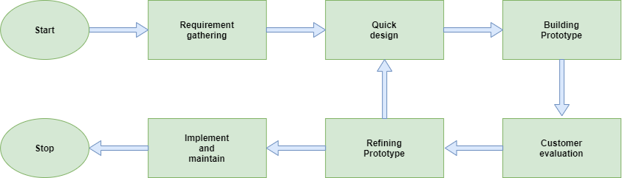

Figure 1: Prototype Model

There are some advantages and disadvantages using this model. A value has given to user, User has involved with the system as an active member in the project. User can get a better understand about the system overall. Error recognition is easy compare to other models. System can be developed to an error free environment using user feedbacks. It takes less time to develop the prototype to a complete system using quick user feedbacks.

The disadvantages using this prototype method is there is high possibility, increasing the complexity of the system going to develop. The project can expand its boundaries beyond the initiation. It will increase the budget as allocated to develop the system, time and the technology that has used in the system. Incomplete system can cause many difficulties to customers using it, it can lead to reduce user satisfaction about the system.

Prototype model is suitable for a system which has lots of end user interactions. It can be used for online systems and web interfaces. It takes time to develop a user-friendly end user interface but user no need additional training to use the system at the end. Active users give feedback to the system it can be used for system development, make it fully working error free system (Tryqa, 2013).

## 3.1 Planning

New smart parking system should build to overcome issues involved with traditional parking systems. Traditional parking systems has less features compare to smart parking. In a traditional parking there is major human involvement for maintain the parking system, user authorization, bill payments should be done manually this method can takes more time compare to smart parking. In a traditional parking system, it’s difficult to establish a parking slot booking system and user can’t get an idea parking is full or there is available space in the parking before entering to it. In security wise traditional parking is in a low position compare to smart parking, in a smart parking system user get constant warning messages to their mobile.

Street parking also popular parking method use in town areas, people park their vehicles side of the roads which is quite easy but improper wrong street parking can cause road accidents, block roads which can leads to traffic in town areas. If someone one is going to park his vehicle for a long-time street parking not the idealist method because he’s blocking the availability of other people to park their vehicle there. He should use a proper parking lot for that

The project should be able to overcome the problems traditional methods exist and increase the user satisfaction about parking

### 3.1.1 Identifying Business Values

The purpose of the project is giving user more advantages and help them to fulfill their needs without putting them to uncomfortable situations what traditional parking can cause them. New smart parking solution is a private parking in urban areas, user should register to use it, there is a registration fee, which is costly than traditional parking. Registration time valid for one year. Compare it with traditional parking user can get more features like less time consume methods for authorization, pay bills through web based myparkbot parking app, online booking, safety warning notifications, show availability of parking in real time on app etc. In this way, the user can get more features for a fair price compare to using a traditional parking.

Smart parking has minimum human involvement compare to traditional parking which means a smaller number of jobs available in smart parking, in business wise it is not a good solution for a country which has higher unemployed rate

### 3.1.2 Feasibility Analysis

Feasibility analysis is an evaluation process to make sure that the product introduced to the market will work correctly and will it be able to give the correct outcome and will it give benefits and good profit to the organization. This can be checked as technical, financial, operational, organizational, legal and schedule feasibility.

#### 3.1.2.1 Technical Feasibility

The technical feasibility concerns how will system deliver the outcome in technical side. Ability to make system risks, fail to attain benefits, cost and time overruns, inadequate system performance levels, unable to integrate with existing hardware and software. I used NodeMCU ESP 8266 and Arduino UNO R3 as main micro controllers for this project. NodeMCU is a less costly microcontroller that can connect to Wi-Fi. I used this for connect sensors with online database. Arduino has use to connect other components with the system. Cording has written using Arduino IDE software using C language. To send sensor values to the online database and retrieve date from database, I used php programming language. For update the database without refreshing I use JavaScript. To create a system using these components it requires the knowledge in these components and how to use them correct way. Smart parking web-based app Myparkbot I has developed using PHP, HTML, JavaScript, CSS programming languages

#### 3.1.2.2 Financial Feasibility

In financial feasibility it mainly has analyzed Cost benefit of the project. I tried to make this project cost effective way. The components I used for this project is in affordable price. I have used here basic level of hardware components. The accuracy and reliably can increase using high end sensors and devices also there will be high cost.

#### 3.1.2.3 Operational Feasibility

Like hood of project attaining desired objectives, how new system will affect organizational structure and process, how it will fit to current day to day operations. To work Hardware components correctly there should be a proper power supply. Voltages levels and electricity levels are different vary from one device to another. NodeMCU ESP 12 8266 operate current is 3.3V but the sensors usually 5V. If sensors connect to 3.3v pin of the micro controller it is unable to supply enough voltage for sensors in that case I used voltage level Shifter 3.3V to 5V. To supply DC power supply for hardware components I used 18650 rechargeable batteries. NodeMCU has Inbuild WI-FI enabled chip, it can connect Parking database through internet

#### 3.1.2.4 Organizational Feasibility

How key stakeholders in organization view system, system can affect distribution of information, thus power

The organizational feasibility check possibility and concern about the system. It checks if the system has enough skills also enough resources to bring the system to the market. It concerns whether the product/system will be successful in the market.

#### 3.1.2.5 Legal Feasibility

Copyrights, anti-trust laws, financial reporting requirements, contractual obligations, software ownership, outsourcing arrangements

In legal wise minimum age to use the parking is 18, user must have their driving license with them. Age can be different with countries; however, parking system must follow rules declared by the government of the country. All user must follow the rules and regulations of the smart parking system. The gathering information from users must prevent from getting compromised, should avoid any 3rd parties getting access to that information

#### 3.1.2.6 Schedule Feasibility

Like hood that timeframe can be met and that this is adequate to meet organization’s needs . resource availability to enable schedule

It requires the knowledge in many fields to complete this project electrical and electronics, Arduino, sensors, Database, MySQL, C language, PHP, HTML, JavaScript, to finish this project successfully need to have this knowledge. Data gathering methods should use to get an idea what is the opinion of the society about project topic

### 3.1.3 Work Plan

The time period has given to complete the project is 6 months . The work plan of the project has separated and described as milestones in the project. First milestone of the project was Project starting/Beginning. The starting time period of the project is end of the July 2020 and end time of the project is beginning of January 2021. Draft proposal submission, Proposal presentation and project proposal submission have done fist milestone of the project proceedings. The tutor has selected a project title and it has proposed to the university as the project proposal. Tutor has granted approval for the proposal which has submitted to the university, it has proceeded to the second milestone. The second milestone of the project was Preparation Part. The tutor has done information gathering to start the project and make it successful. In this preparation part tutor has proceed to obtain requirement skills for the project, choose a layout for the parking system going implement in the future, design parking lot layout what components should add and how they should be in the parking, choose hardware components for the parking system, in this part tutor has studied what kind of components need for develop the prototype microcontrollers, sensors, motors and other hardware items. In this section, the tutor has studied how to design parking lot web based mobile application what kind of layout it should be for the administrator and for users who is using it after the development of the system. The tutor has studied about database knowledge, Arduino coding and languages use to create web pages I this time period. Third milestone of the project is implementation, in implementation part the tutor has fully design the system, develop the system and carried out testing. In this part the tutor has fixed errors and developed the system to be fully working model. The last milestone of the project was evaluation and prepare the project report. In this part the tutor has prepared the project report, test the final prototype which developed for the project, done critical evaluation and discussed the positive and negative sides of the final outcome.

## 3.2 Analysis and Requirement Gathering

### 3.2.1 Analysis

To fulfill the increasing number of vehicles on roads especially in city areas, traffic congestions also goes higher also the accident road accident rate goes higher. There is a need of much large spaces to park vehicles also do it in an efficient way with less time consumption that’s where the smart parking concept comes to the society.

### 3.2.2 Requirement Gathering

The data gathering is an important task to make the project successful. The outcome of the project experienced by the end users, people who is in the society, feedback of the users is important factor. Data gathering can be done mainly in two methods primary data gathering and secondary data gathering. In primary data gathering the tutor of the research collect data directory from people using methods like questionnaires. In secondary data gathering the tutor analyze the date what already has gathered by other researchers, use that information to understand the problem.

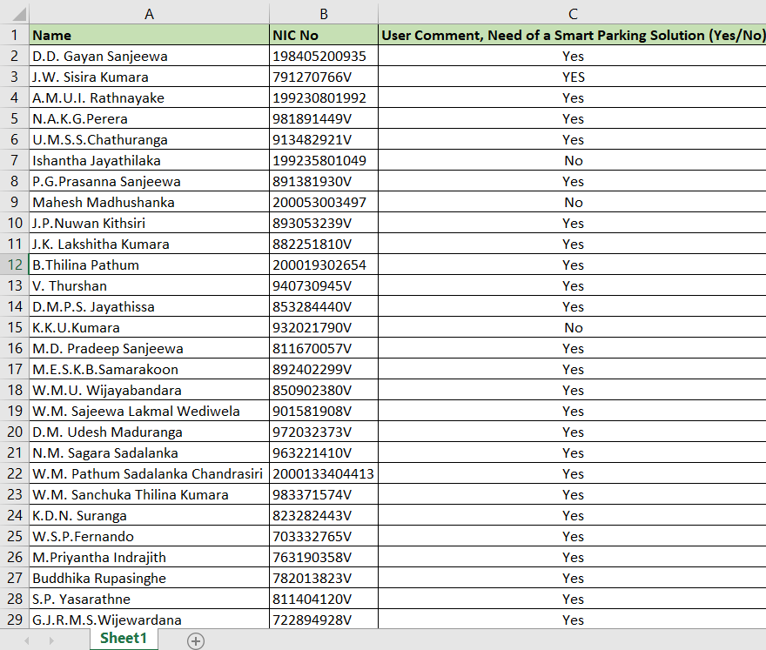

Table 1: Data gathering using questionnaires

The tutor has gathered information related to need of smart parking system using questionnaires and created a datasheet using that information. The final analyzed results have shown in the pie chart below

Figure 2: Pie chart Need of smart parking solution

The pie chat shows that 95% of people have agreed with there is need of smart parking solution

Only 5 % people disagreed with the new system. Compare the befits the new system has with traditional system most people have agreed to there is need of new system to save time, reduce road accidents and safety.

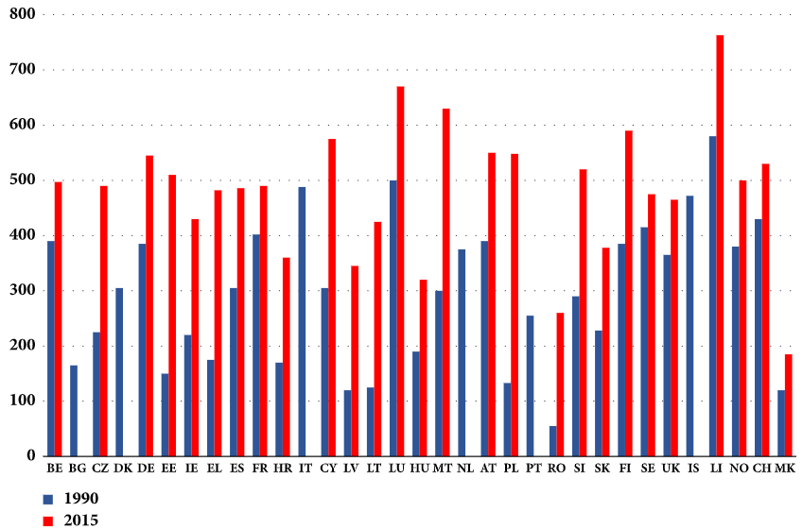

Figure 3: The increase in the number of passenger vehicles per 1000 inhabitants in EU (M Alam, 2018)

Above bar chart has shown the increase the number of vehicles per 1000 inhabitants in European countries. The researcher has analyzed the data 1990 to 2015. It has shown in the figure how passenger vehicles have increased through the period of time. The researcher has suggested intelligent smart system as for the solution increasing number of traffic.

## 3.3 Designing

### 3.3.1 Physical Design

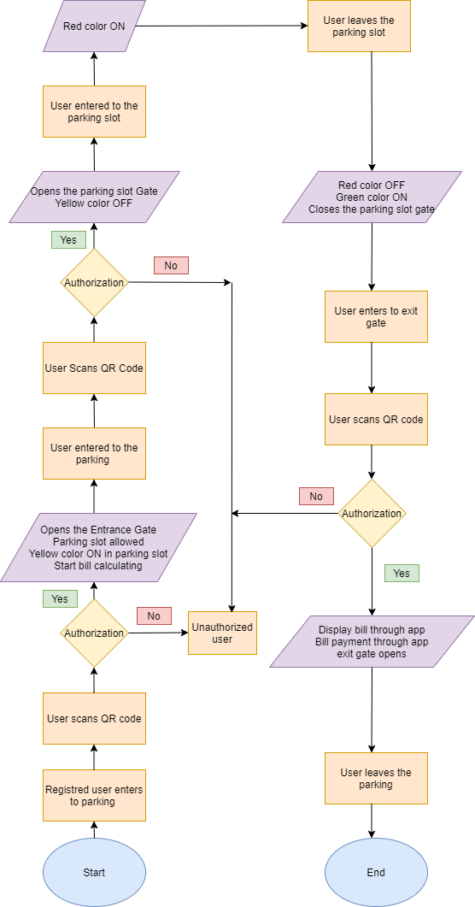

Figure 4: flow chart of parking system for registered users

The designed parking system has given user web based mobile application to interact with the parking system. Above flow chart has shown how it would be when a register using the system. User can register to the parking system given user information what system required. All registers users are given unique QR code for authenticate themselves in the parking. This is 16-bit code includes numbers and letters, the complexity of the code has increased due to security reasons. It also can be considered as user ID. User can see the QR code on their mobile app, when a user came to the entrance of the parking the user scans QR using the QR scanner mounted in the entrance. If the user is a registered user, the system matches user QR with the database of the parking and given access to the user. A successful authentication opens the entrance gate for the user, in the same time the user is given a free parking slot in the system. The user can see which parking slot is allocated through MyParkBot mobile application installed in user mobile phone. Bill calculation process starts in the authentication phase at the entrance gate. The user can easily find the parking space allocated because it shows with the parking slot number. Authorized user now enters to the parking slot spaces in the system and go the particular slot shows in the mobile. In every parking slot has a gate, QR scanner and 3 lights mounted the top of the parking slot which are Green, Red and Yellow color. If the parking slot is free it shows in Green color, if the parking slot is full it shows in Red color, if the parking slot is booked it shows in yellow color. User comes to the write parking slot and scans the QR the gate open, it can only open using allocated user QR. The user is allocated/booking a free parking slot at the entrance. The allocated parking slot displaces in yellow color in both on mobile and in the parking slot. Mobile application interface has given user to get an idea what is free, full and booked in the parking system parking slots are show with relative colors. User opens the gate and when entered the vehicle to the parking slot yellow color changes to red color booking status to slot full status. Parking slot gates automatically when there is no vehicle in the parking slot user no need of close it, when user exits the vehicle red color turns into green color again it indicates that parking slot is free. The color pattern changes in parking slots and on app interface in same way in real time. User goes to the exit of the parking, there it has mounted QR code scanner when user scans user QR using QR scanner it shows the bill according to how much time user has spent in the parking. Bill payment automatically debited from user account using smart wallet created in the system and opens the exit gate. User leaves the parking system.

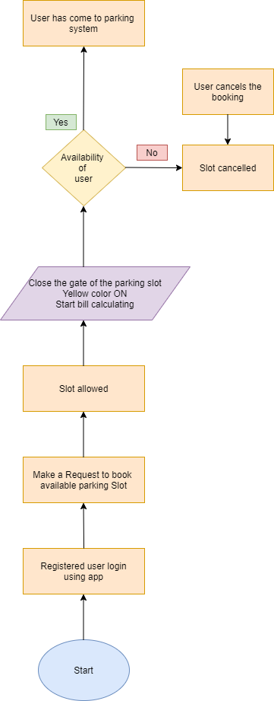

Figure 5: flow chart of booking in the parking system

The system has allowed user to reserved/booked a parking slot before enring to the system. One user can only select one parking slot at a time. Users are allowed to book a parking slot 1 hour before the booking time, as an example if a user want to book a parking slot from 11 A.M the user will be able to book a parking slot from 10 A.M on the same day. User can’t select parking duration for example 11 A.M to 1 P.M. user can’t select an end time. End time is when user leaves the parking slot. This method has used to prevent irregularities that can happen in the parking. The booked user is late to enter to the parking system, the slot will be cancelled in 15 minutes automatically in free of charge by the system. This method has used to save parking slots in the system and allow them other users to use it. The flow chart has shown above booking proceeding of the system. Registered user login to the system and booked a free parking slot available at the time. Free parking slots have shown in green color in the user interface of mobile app and select time, when the slot is allocated it shows in the interface to user. Gate of the allocated slot closes when booking happened, yellow color turns on in the parking plot in the system and bill calculating staring to the relevant user. User can cancel the parking slot before the booking starts, in above example before 11 A.M. booked user can do the payment at the exit gate.

### 3.3.2 Architecture Design

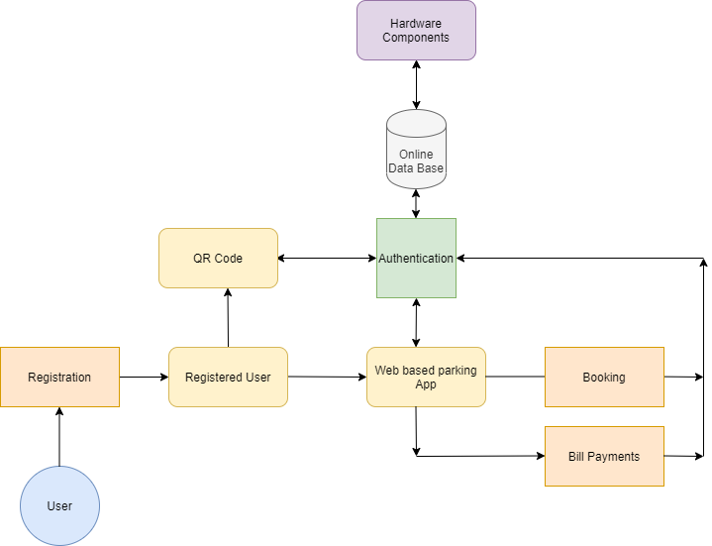

Figure 6: Architecture design of the parking system

Register user has unique QR code which is generating by the web-based app related to his account. This code has used to identify his identity in the parking it has used to user authorization. All the date stored in online data base. Hardware components have connected with it and they send and retrieve data

### 3.3.3 Interface Design

Figure 7: Interface design of My Park Bot Application

My parking Bot has several user-friendly features It shows parking slot availability information in real time, parking slot booking, generate QR code, User registration also it acting as a smart vault

Below sections the tutor has described user interface that has included in the My Park Bot web-based application. This application has given to the user of the parking system. The users can manage their parking using it. It has created with a user friendly design, it helps for customers to use it without additional knowledge.

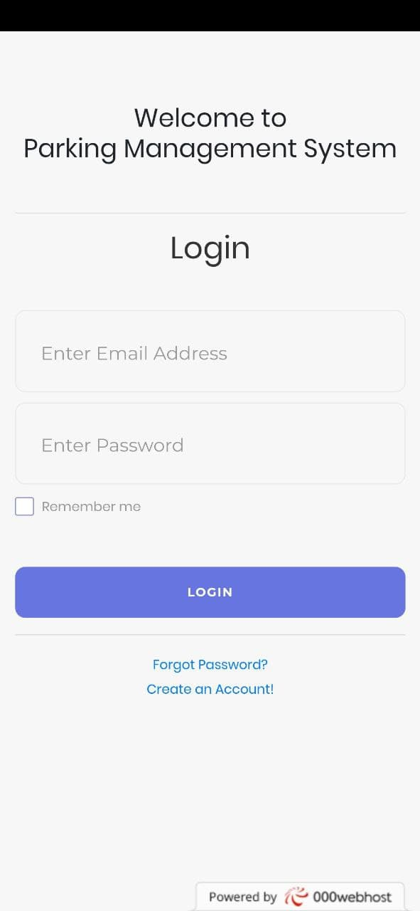

Figure 8: User log in interface in web based mobile application

This is the login user interface design has created for users. User can create an account or registered users can login to the parking management system. The website has hosted using free hosting server called 00webhost.

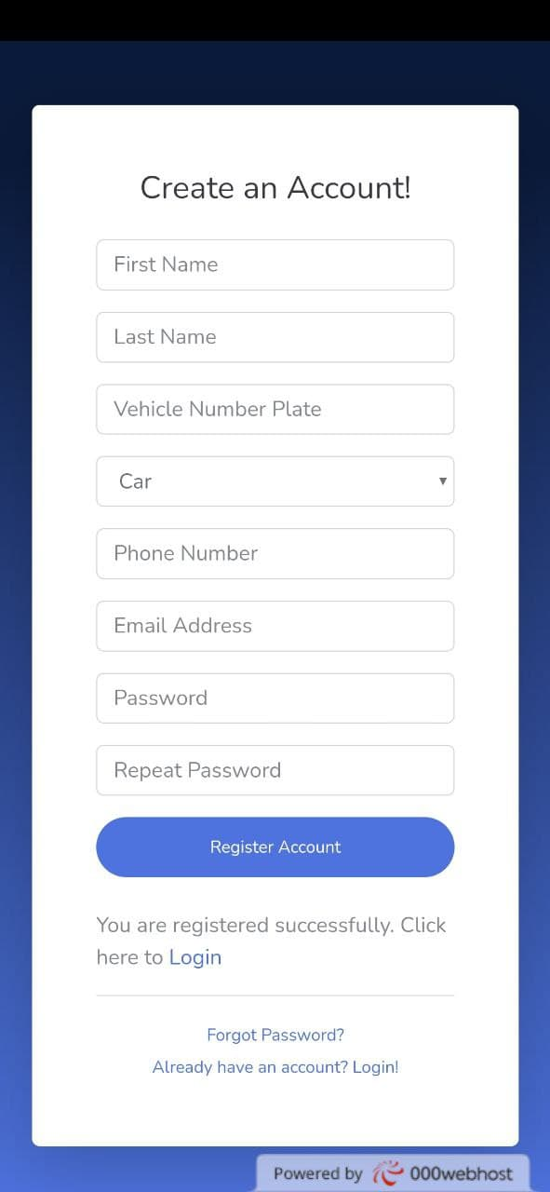

Figure 9: Crete user interface in mobile application

Above user figure shows create account interface has created for users. It has included user first name, last name, vehicle number plate number, vehicle type, phone number, email address and the password. After creating successful account user can login to system using this interface.

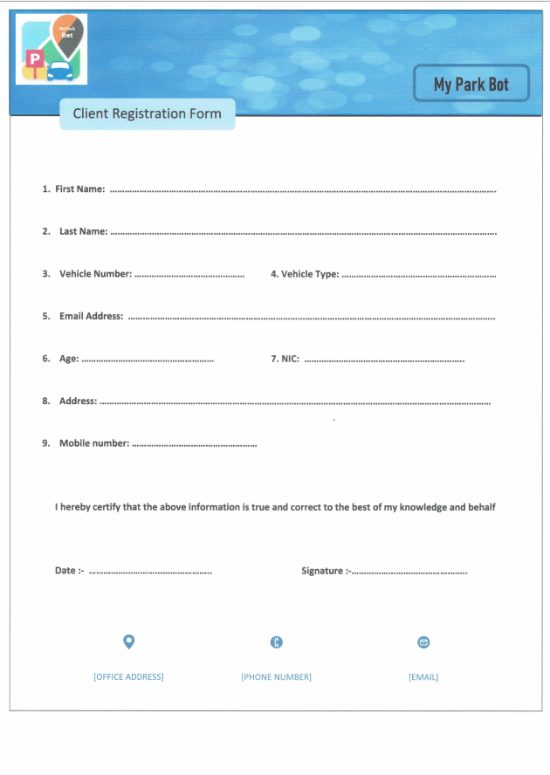

Figure 10: My Park Bot registration form

My Park Bot registration form has created by the administration for customers who is having difficulties online registration. User can fill up the form and email it to the administration or user can post or handed it over to the My Park Bot parking system, after receiving the application administration can add users to the system and they are given a QR code by the administration.

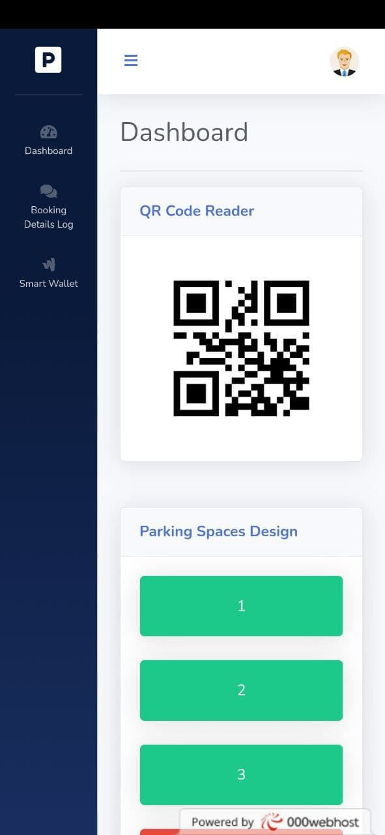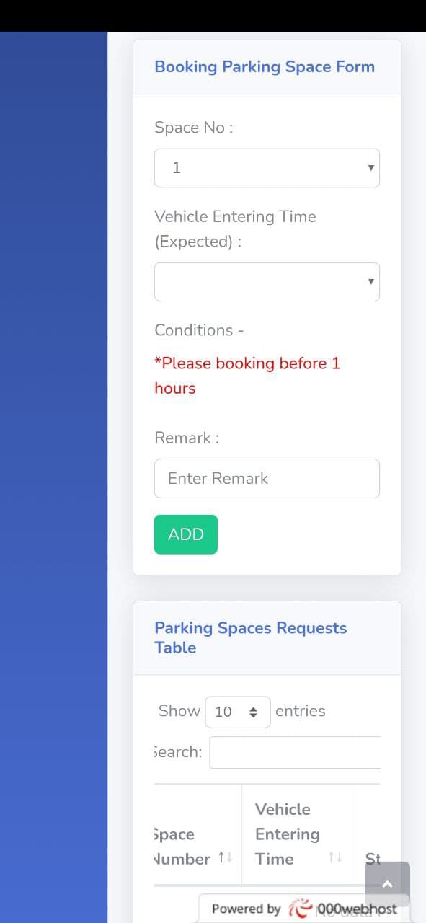

Figure 11: User dashboard on mobile application

This is the system dashboard for the user, it has included user QR code, parking space design, parking slot booking space form and parking space request table. QR code has used to authenticate users, users scan this code using QR scanners in the parking. Parking space design has shown in the dashboard, user can book a parking slot online using booking parking space form. Parking space request table shows details according to user booking space number, vehicle entering time, status, remark, user email and using this user can cancel booking free of charge.

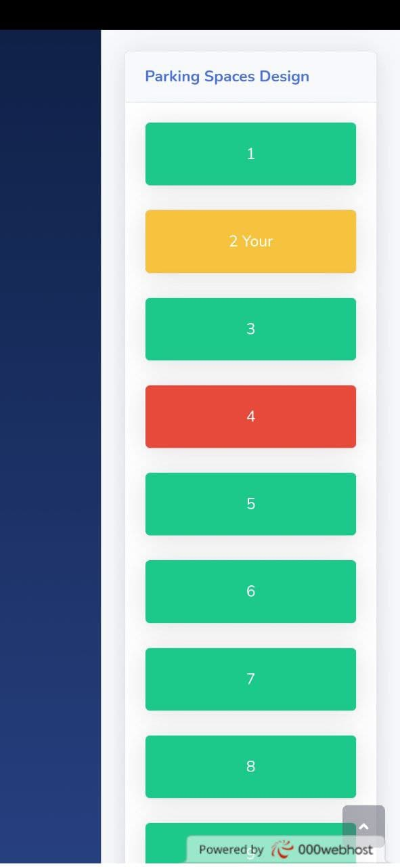

Figure 12: Parking space design on mobile application

Above figure shows parking space design, parking slots has indicated with green color are free parking spaces in the parking system, slots which have indicated with yellow color are booked parking spaces in this case it is the related perking space which has booked for this user, It has indicated with “Your” which helps user to identify his/her parking space.

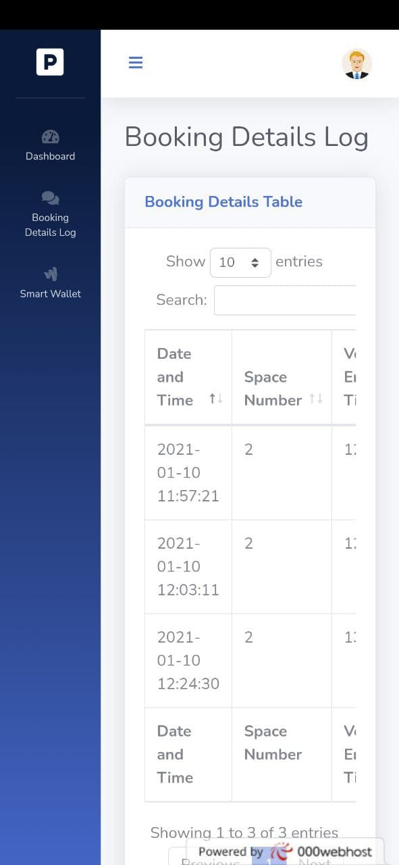

Figure 13: Booking log details table on mobile app

Booking logs table includes date and time, parking space number, vehicle entering time, status, remark, email address and booking status. It helps end user to understand about user booking details in the parking

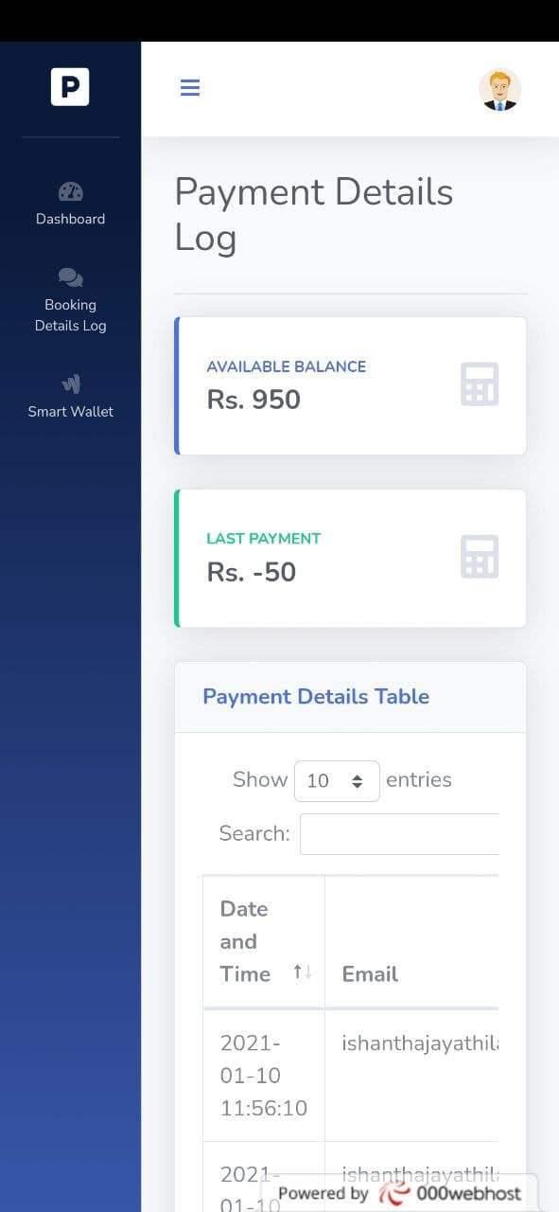

Figure 14: Smart wallet on mobile application

Smart wallet shows payment details logs. Rs. 1000 Rupees has been added to a new user in the registrations. According to the usage of the parking it will reduce form the user account as a payment. User can see available balance of the user account, last payment done by the user and parking details table, it includes date and time, email address of the user and price that has been debited from the account.

Tutor has shown in the below section how is the interfaces has designed in the Administration/management side of the system. Interfaces has created using mainly PHP, CSS, HTML and JavaScripts languages. User friendly interface design given ability for the admin to understand and manage the system easily.

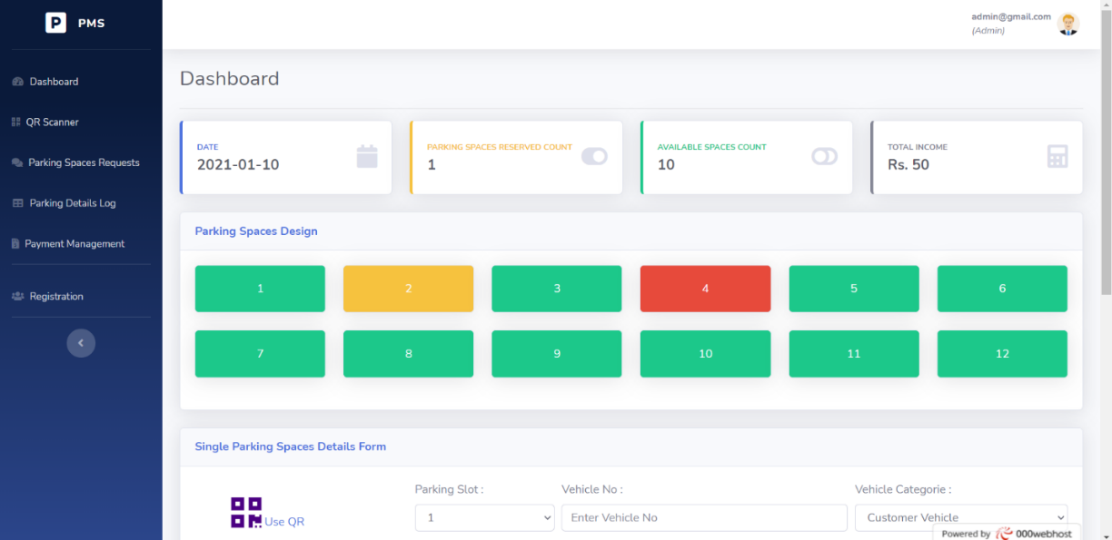

Figure 15: Administration dashboard in parkin system

The administration dashboard shows real time data, parking spaces reserved count, available parking space count, Total income of the parking, parking spaces design and single parking spaces details form, it helps admin to add vehicles manually for the parking system in case of important situation. Office vehicles or exclusive vehicles can be added to parking this way. Administration dashboard updates in real time with the prototype has created for the project.

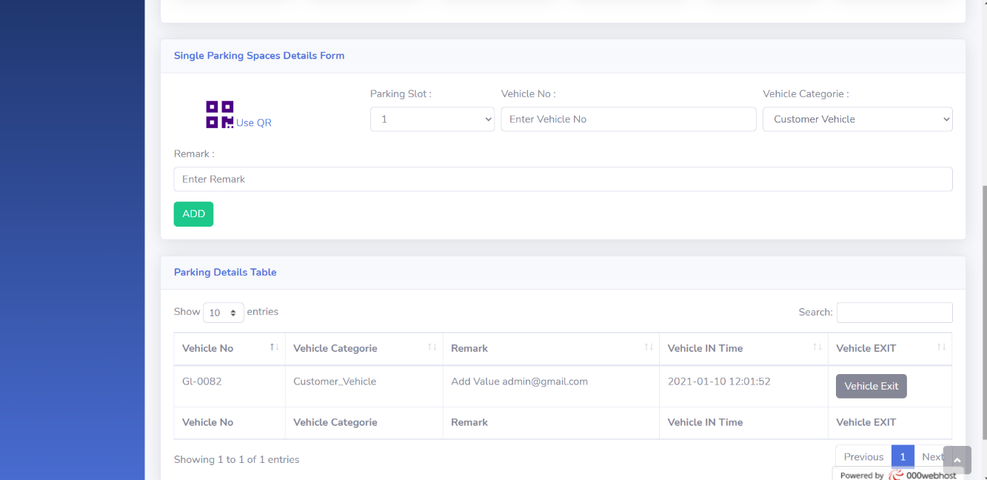

Figure 16: Parking details table

Parking details table has shown vehicle that are entered into the parking. Administration has permission to exit vehicle and free up the space if it is necessary.

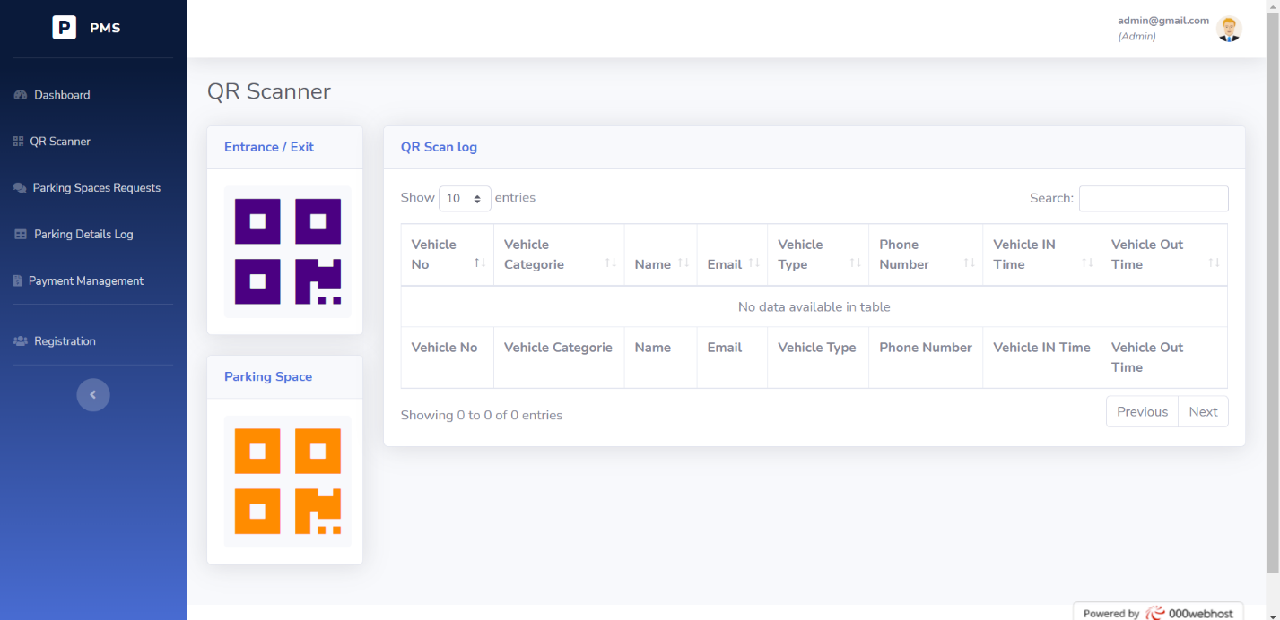

Figure 17: QR scanner

There are two QR Scanners have used in the system, one has used for the entrance and exit of the parking other one has used for parking slots, inside the parking system. Users scan the given QR code at the entrance and exit of the parking to authenticate themselves to enter and to exit in the parking users scan the QR code in parking slots to authenticate themselves inside the parking. When user entered to parking user need to scan QR code using second (parking space) QR scanner to open the parking slot gate. This method has used to secure user parking spaces it has prevented unauthorize access inside the parking.

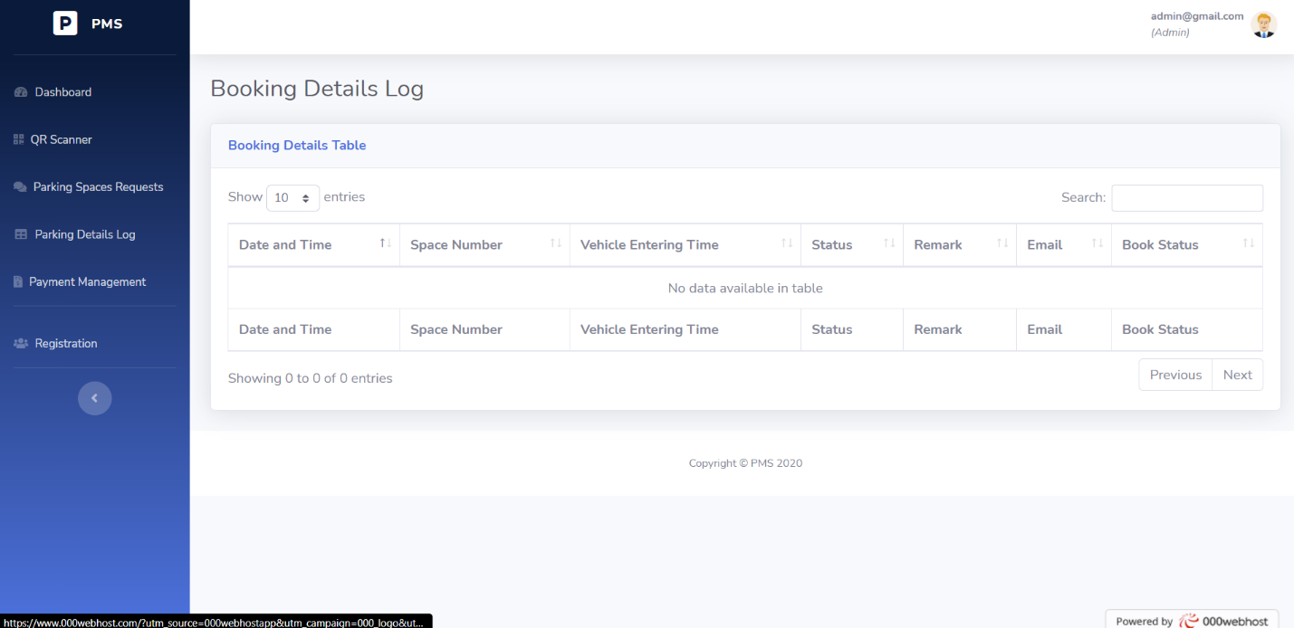

Figure 18: Booking details log

Administration can get details about booking referring log details, it has included date and time, parking space number, vehicle entering time, status, remark, user email and booking status

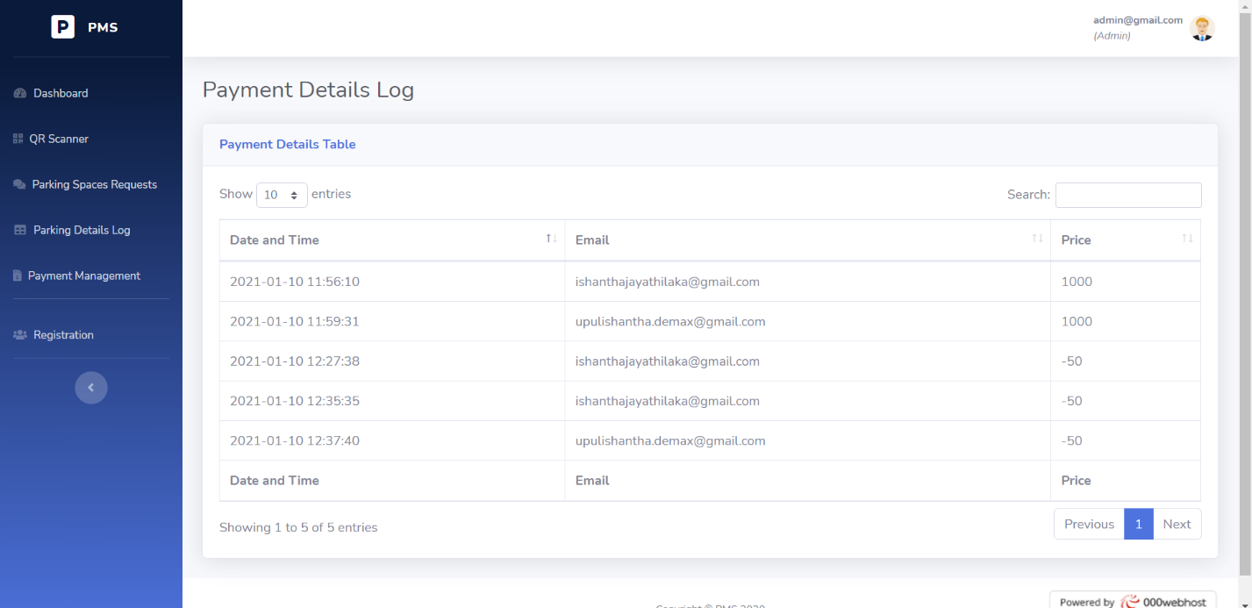

Figure 19: Payment log sheet log

Above figure has shown payment details table in the system. It has mentioned the data and time, email address of the user and the price. Management of the parking can get details about user account balance that has used for parking.

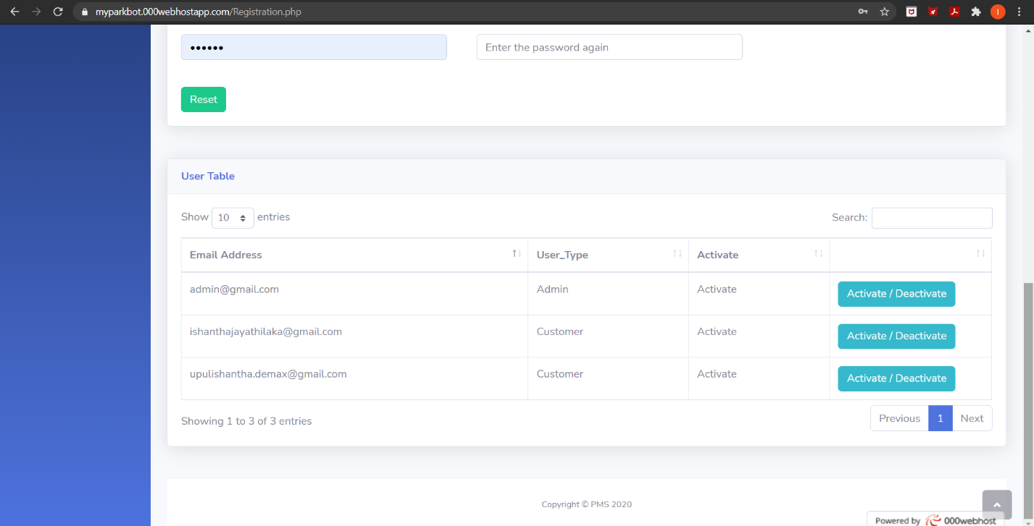

Figure 20: User Table

User table shows registered user account in the system. It includes email address, user type and active didactive status. It has given permission for the administration to activate and deactivate user accounts.

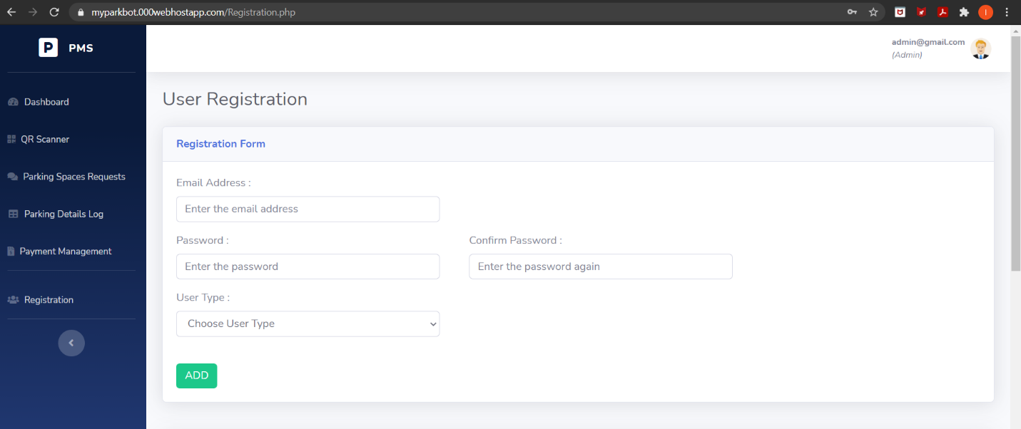

Figure 21: User Registration

It has given permission for the management of the parking to add user manually for the parking. Users who are unable to register online can be added to the system this way.

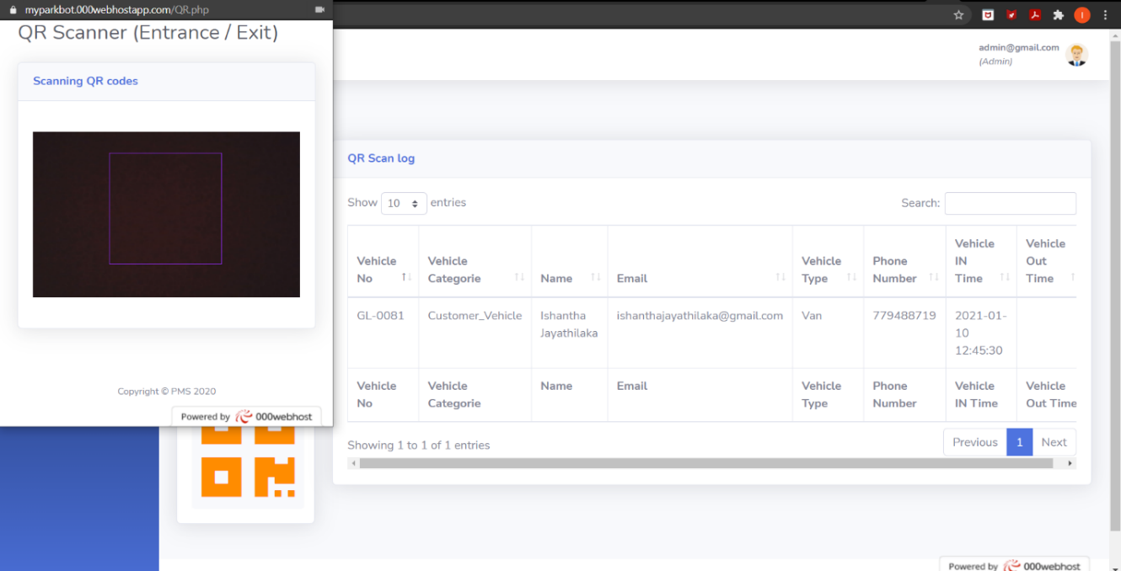

Figure 22: QR scanner entrance and exit

Above figure has shown active QR scanner interface in entrance and exit gates. When a user shows QR code Infront of the scanner it detects if it’s a valid QR or invalid QR

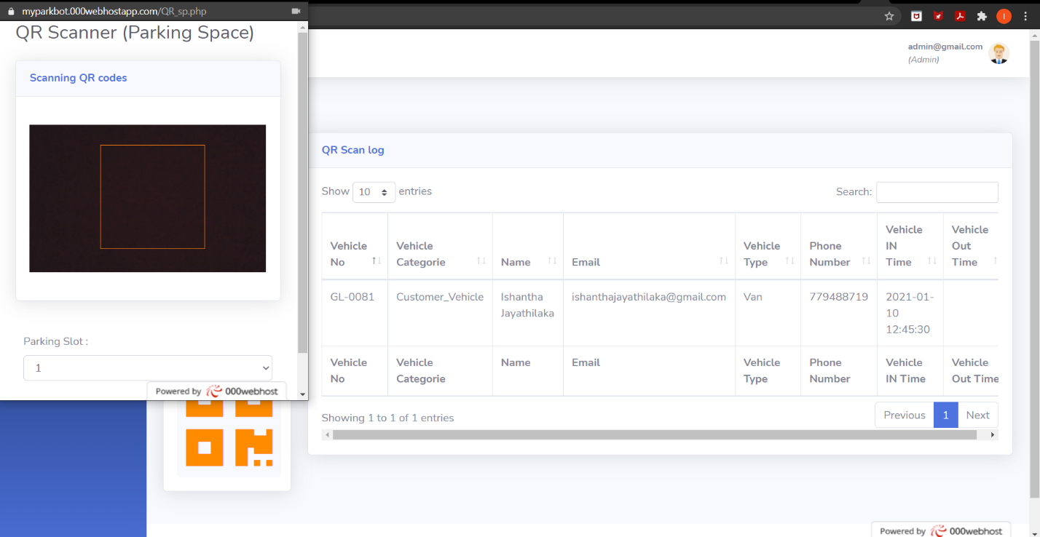

Figure 23: QR scanner parking space

Above figure has shown the active QR scanner in parking slots, this scanner control gates of parking slots. It prevents unauthorize access and secure user parking slots.

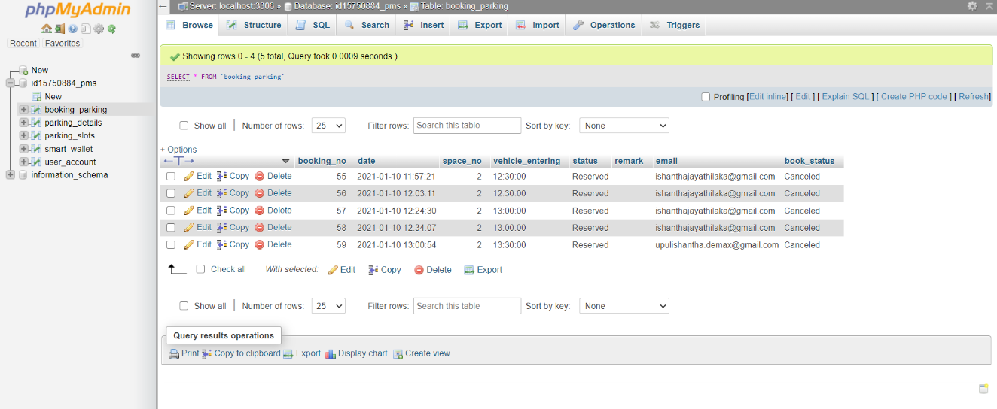

Figure 24: My SQL database

My SQL database created for parking has shown in above figure. This is backend of the system all user information have gathered here and the current status of the system. It has five tables booking_parking, parking_details, parking_slots, smat_wallet and user_account.

Figure 25: Interface design of Parking lot Management

Parking lot management Admin side has connected with online database, parking lot management can control the situation in the parking lot, also the QR scanners in the parking lot has connected to this side

## 3.4 Implementation

Figure 26: Implementation design of the parking system

NodeMCU ESP 8266 has connected with Ultrasonic sensor HC-SR04, Servo motor SG90, LED Red, Green and Yellow. NodeMCU also has connected with Online database through Internet.

In warning system in the parking Arduino UNO R3 has connected with GSM module SIM 900 it has connected with Flame sensor to detect any fire in the parking space, it can send warning messages to users if there is a fire

Parking slot design circuit

Figure 27: Parking slot design bread broad diagram using fritzing software

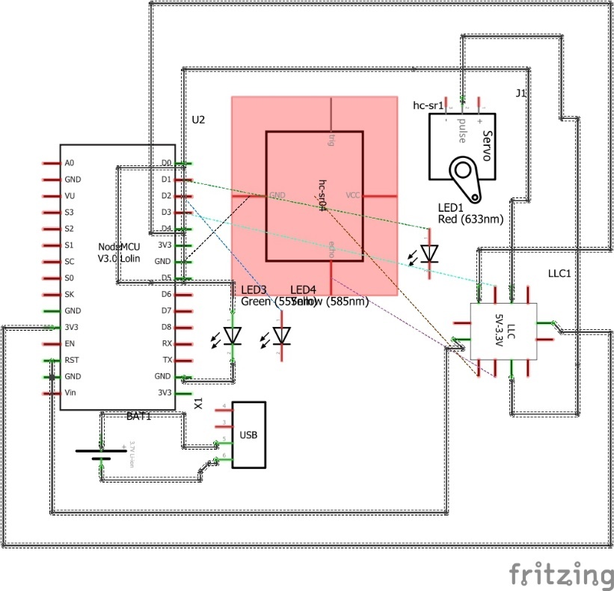

Figure 28: Schematic diagram of the parking slot using frizzing software

Entrance/Exit gate design circuit

Breadboard diagram

Figure 29: Entrance and exit design bread bored diagram using frizzing software

Schematic Diagram

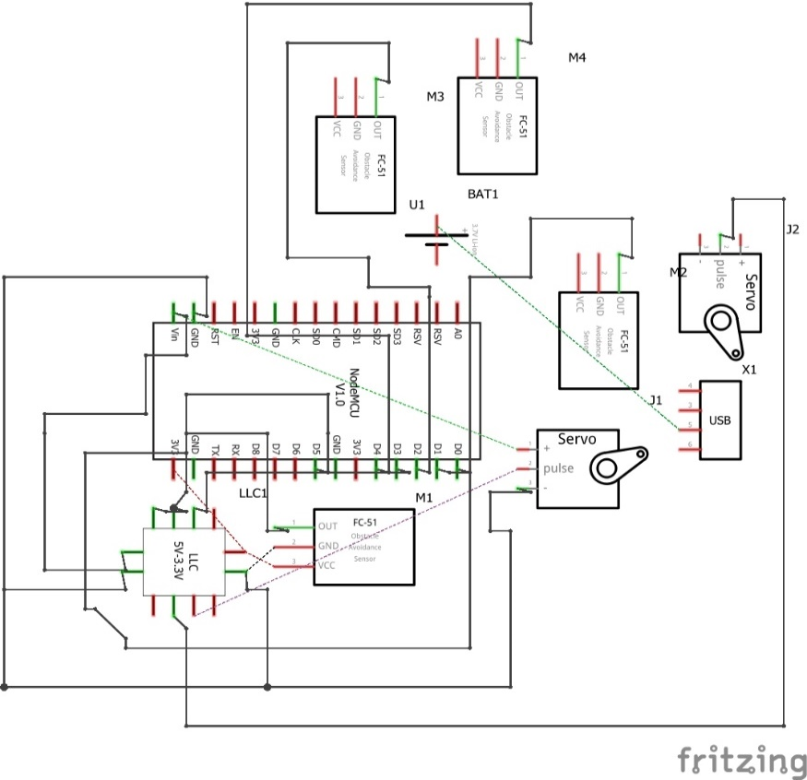

Figure 30: Entrance and exit design schematic diagram using frizzing software

Breadboard Diagram

Figure 31: User warning system bred board diagram using fritzing software

Schematic Diagram

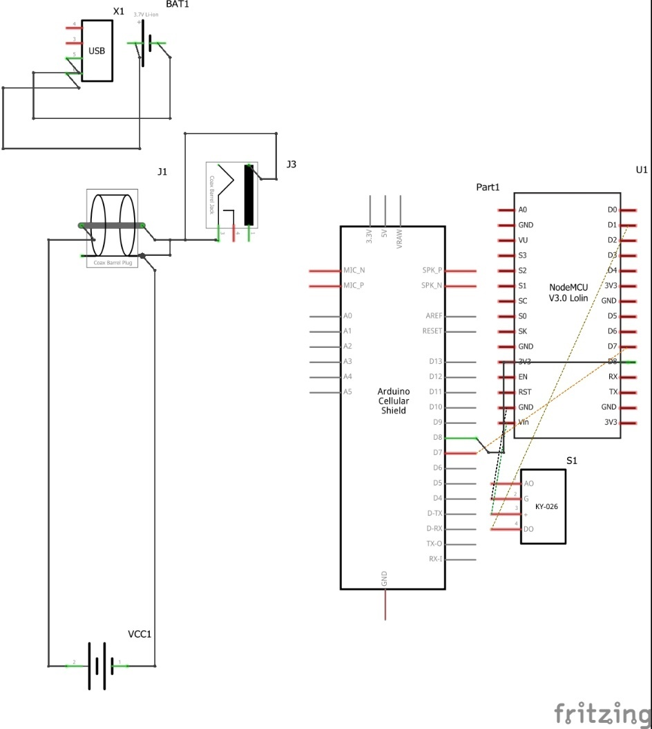

Figure 32: User warning system schematic diagram using fritzing software

## 3.5 Testing

### 3.5.1 Unit Testing

Unit testing 1

Ultrasonic senor HC-SR04 has used for making the protype, in unit testing one the tutor has verified that the sensor has used working properly

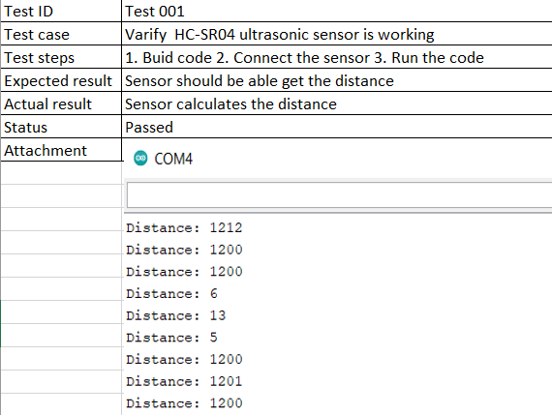

Figure 33: Unit testing 1 verify ultrasonic sensor is working

Unit testing 2

Servo motor SG 90 has used to build the prototype, in unit testing 2 the tutor has verified that the motor working correctly to achieve the outcome

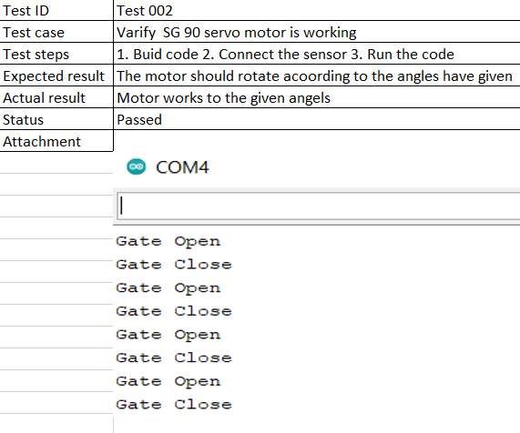

Figure 34: Unit test 2 verify servo mother is working

Unit testing 3

Obstacle avoidance sensor infrared has used to develop the prototype, in unit testing 3 IR sensor has checked and verified that there are no errors

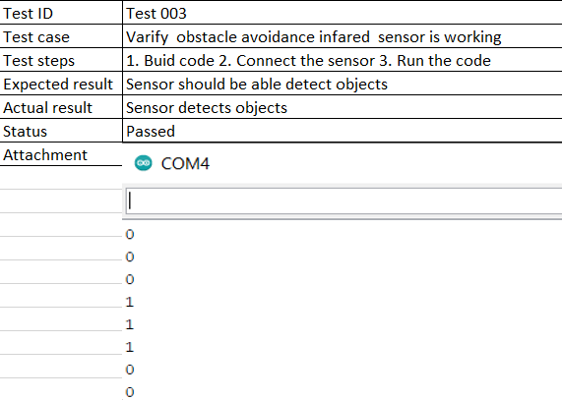

Figure 35: Unit test 3 verify IR sensor is working

### 3.5.2 Integration Testing

Integration testing 1

Ultrasonic sensor has used in the project to check availability of the parking slots. When it detects an object, it has functioned to send values for the data base, when there is vehicle in the parking it takes as active slot, when there is no vehicle in the parking slot it takes as empty slot. Two LEDs have connected to circuit in active statement red led lights up inactive statement green LEDs lights up.

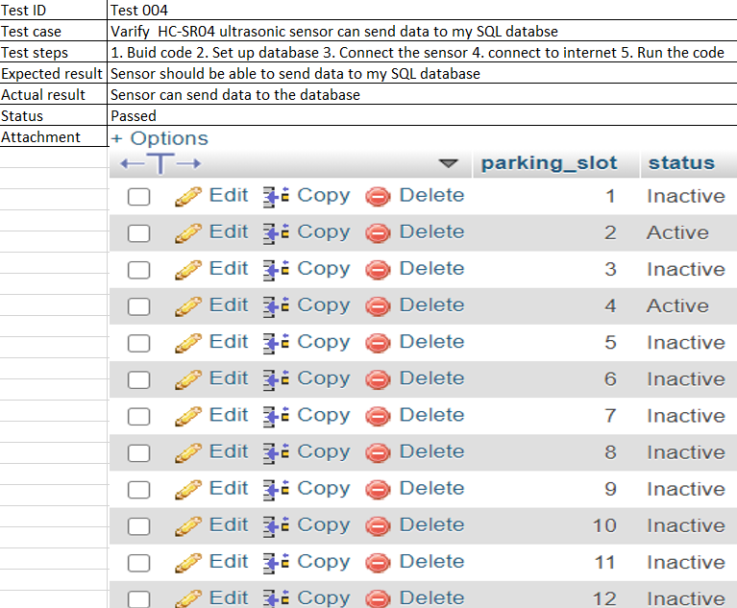

Figure 36: Integrating test 1 send data to MySQL database using ultrasonic sensor

### 3.5.3 System Testing

System testing 1

The tutor has checked and verified entrance and exit QR scanner working correctly in system testing 1

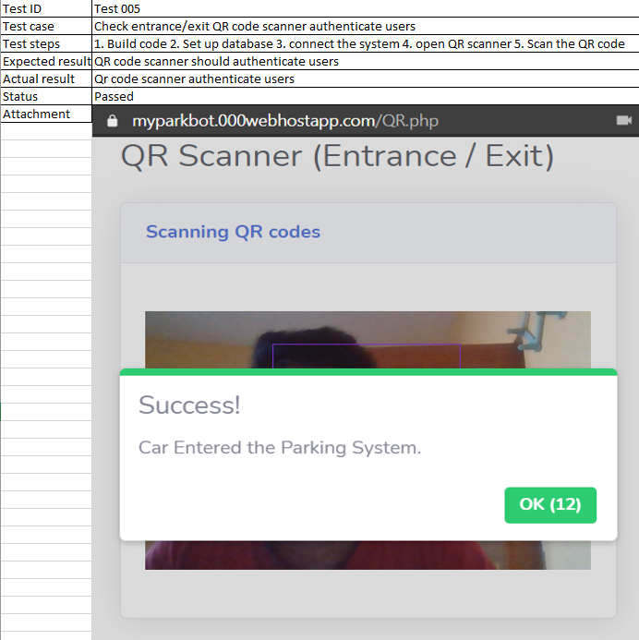

Figure 37: System testing 1 authenticate user using entrance exit QR scanner

System testing 2

In system testing 2 the tutor has checked and verified that user authentication and smart wallet working in the system.

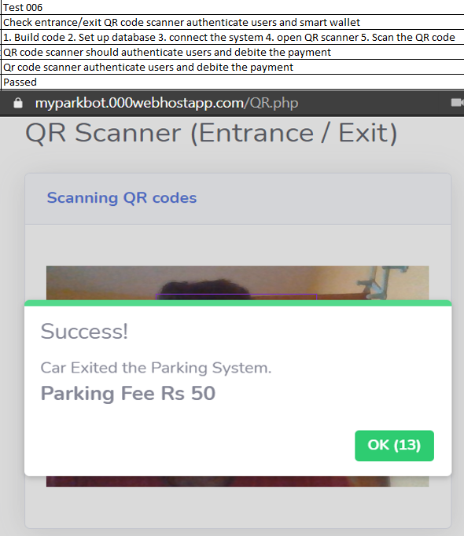

Figure 38: System testing 2 Authenticate users at the exit and smart wallet

System testing 3

The tutor has checked and verified that administration dashboard is working properly

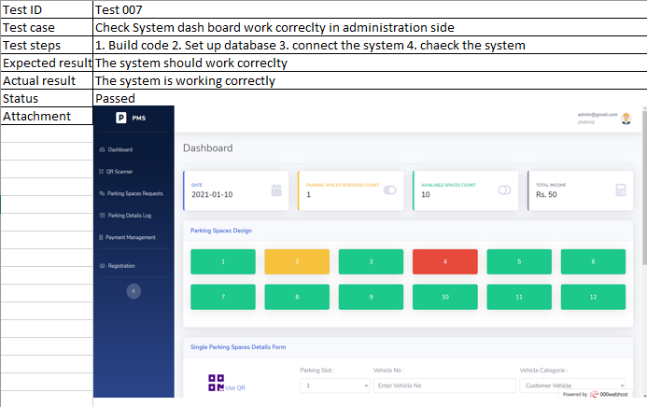

Figure 39: System testing 3 administration dashboard check

# Chapter 04 – Artifact

## 4.1 Academic Findings

(Khanna & Anand, 2016) proposed IOT(Internet of Things) based smart parking system. This IOT based cloud integrated smart parking system given as a solution for traffic congestion, limited car parking facilities, road safety in urban infrastructure. It has a module monitor and signalize the state of availability parking space and booking a parking slot

M.Y.I. Idris, Y.Y. Leng, E.M. Tamil, N.M. Noor and Z. Razak said that “ Current transportation infrastructure and car park facility developed are inable to cope with the influx or vehicles on the road, to alleviate the aforementioned problems, the smart parking system has been developed” also researchers have said that vehicle detection plays a crucial role in the smart parking system (M.Y.I. Idris, 2009).

G. Revathi and V.R. Sarma Dhulipala has explored the concept of smart parking system and their categories, the classification of various technologies also the functions of nodes in wireless sensor networks (Revathi & Dhulipala, 2012)

## 4.2 Sample Code

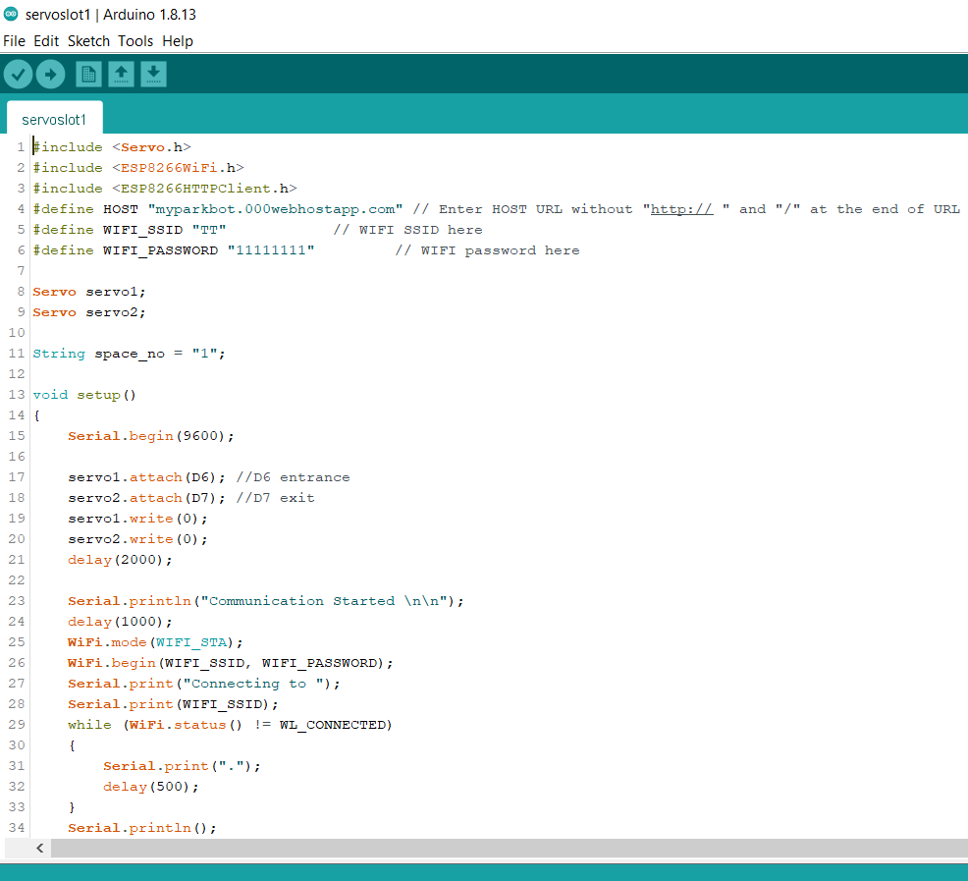

Figure 40: Sample code 1 servo motors

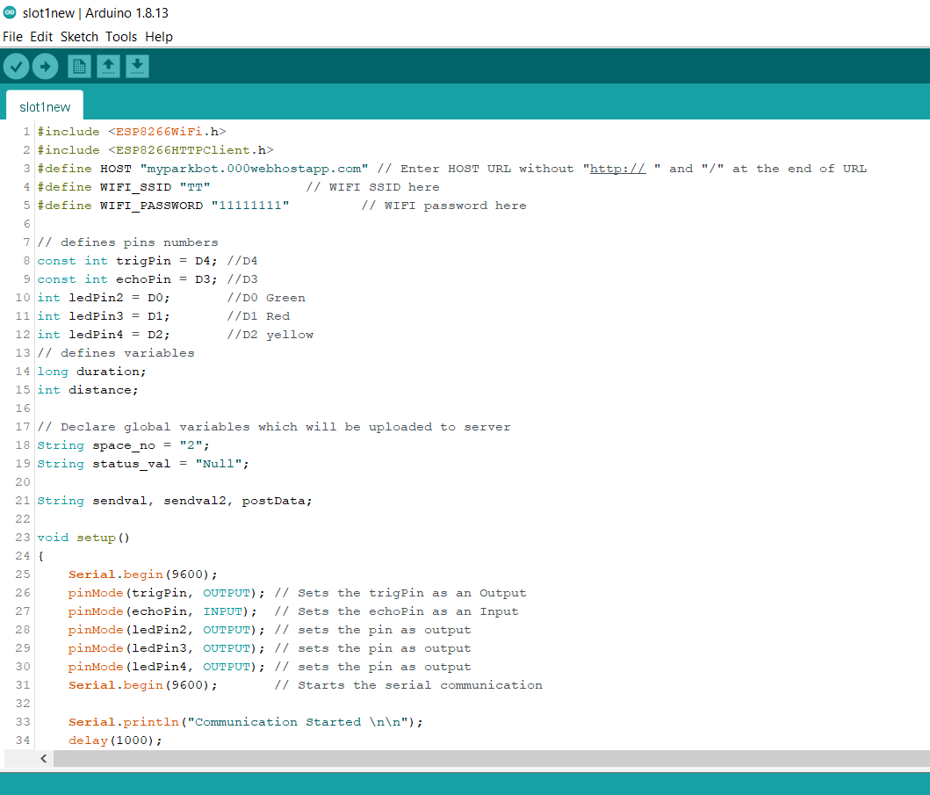

Figure 41: Sample code 2 ultrasonic sensor

## 4.3 Test Cases

Test case 1

The tutor has checked and verified user dashboard is working properly in test case 1

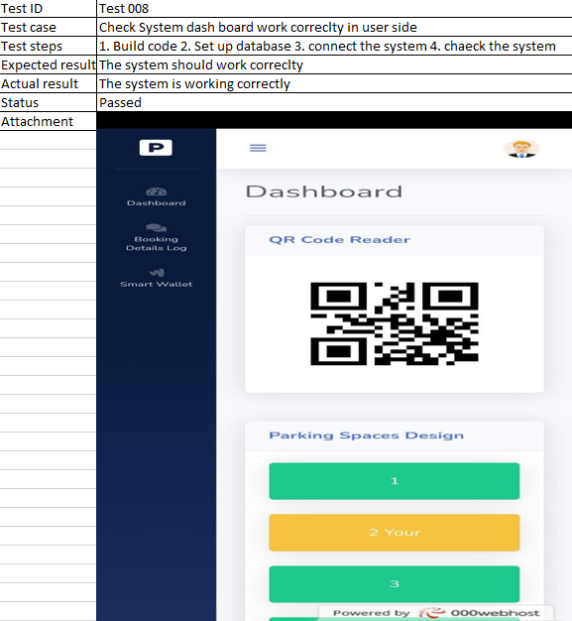

Figure 42: Test case 1 user side system dashboard check

Test case 2

The tutor has checked and verified wrong password combination is not working to log in to the system in test case 2.

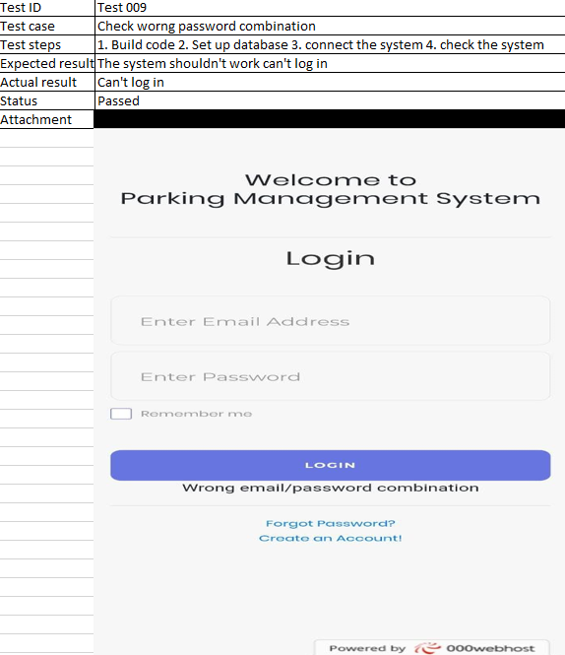

Figure 43: Test case 3 check wrong password combination

Test case 3

The tutor has checked and verified user accidental logout gives waring message to the user in test case 3

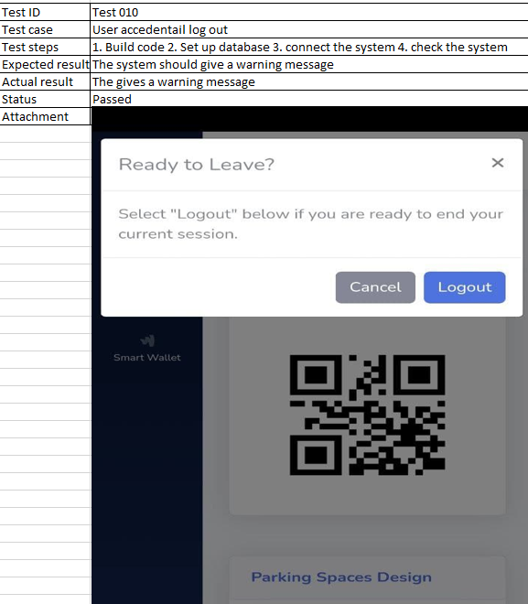

Figure 44: Test case 3 user log out

Test case 4

The tutor checked and verified that user QR is not working for wrong parking slot in test case 4. The System functions correctly

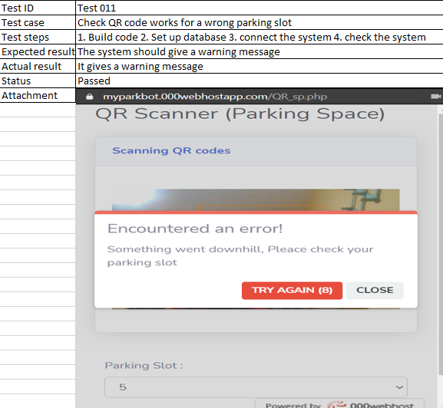

Figure 45: Test case 4 QR authentication

# Chapter 05 – Conclusion

## 5.1Important Outcome

Data analysis part of this project have shown that there is need of better perking system rather than using old traditional methods. Many people have shown interest in new smart technologies. Mobile phone has become most used technological gadget among many people. The system has connected with mobile phone is more continent approach than using a totally different device to connected with the parking system, economically wise it’s saving money. QR code has made the project more convenient, it has superfast reading capabilities compare to any other user authentication methods has deployed today in the same time QR code gives more secured environment to user. Economically it’s a time and cost saving method that can be used to any smart system

## 5.2 Limitation

The system has used only one way to authenticate users, there is no two-factor authentication has deployed in the project. This can be a disadvantage if the primary authentication is failed. There should be smart solution which is compatible with the QR code to use as second authentication in the system. There should more reliable method to authenticate users in the parking.

## 5.3 Critical Evaluation

Building a fully automatic system is possible with great resources hardware and software also it needs high budget, but in the practical situation it’s not something reliable. Because unexpected situations can happen, on that situation the automated system can’t decide how to react to the situation.

## 5.4 Future Work

Add a navigation method, which shows the direction to the user to available, booking parking spaces in the parking lot

# References

18004, I., 2000. *Information technology-Automatic identification and data capture techniques-Bar code Symbology-QR Code,* s.l.: ISO/IEC 18004;2000.

Bachhav, J. D. & M.A., P. M., 2017. Smart Car Parking System. *International Research Journal of Engineering and Technology (IRJET),* 04(06).

cambridge, 2020. *parking.* [Online]   
Available at: https://dictionary.cambridge.org/dictionary/english/parking  
[Accessed 02 12 2020].

Greibe, P., 2003. Accident prediction models for urban roads. *Accident Analysis & Prevention,* 35(2), pp. 273-285.

K.lnaba, M. S. T. N. M. O. N. Y., 2001. *Intelligent Parking Reservation Service on the Internet.* Yokosuka-shi, NTT Service Integration Laboratories .

Khanna, A. & Anand, R., 2016. *IOT based Smart Parking System.* Pune, India, International Conferrence on Internet of Things and Application.

Kuan-Chieh Liao, W.-H. L., 2010. A Novel User Authentication Scheme Based on QR-Code. *Journal of Networks,* 5(8), pp. 937-941.

M Alam, D. M. ,. P. ,. T. G. J. F. J. F. ,. G. R. L., 2018. Real-Time Smart Parking Systems Integration in Distributed ITS for Smart Cities. *Journal of Advanced Transportation,* Volume 2018, p. 13.

M.Y.I. Idris, Y. L. E. T. N. N. a. Z. R., 2009. Car Park System: A Review of Smart Parking System and its Technology. *Information Technology Journal ,* 8(2), pp. 101-113.

Manville Michael, S. D., 2006. *Parking, People and Cities,* s.l.: eScholarship.org.

Mikhail Chester, A. F. J. M. C. F. R. P., 2015. Parking Infrastructure: A Constraint on or Opportunity for Urban Redevelopment? A Study of Los Angeles Country Parking Supply and Growth. *Journal of American Planning Association,* 81(4), pp. 268-286.

Moorhead, P., 2020. Tesla Is Years Ahead Of Competitors With No Signs Of Stopping. *Forbes*, 05 03.

Revathi, G. & Dhulipala, V. S., 2012. *Smart Parking Systems and Sensors: A Survey.* Tamil Nadu, India, International Conference on Computing, Communication and Applications.

Schöb, R. A. &. T. R. &. R., 2005. *Alleviating Urban Traffic Congestion.* edition 1 ed. s.l.:MIT Press Books.

Shoup, D. C., 2005. The High Cost of Free Parking. *Planning Education and Research,* Volume 17, pp. 3-20.

Tesla, 2020. *autopilot.* [Online]   
Available at: https://www.tesla.com/autopilot  
[Accessed 2 12 2020].

Tryqa, 2013. *What is Prototype model- advantages, disadvantages and when to use it?.* [Online]   
Available at: http://tryqa.com/what-is-prototype-model-advantages-disadvantages-and-when-to-use-it/  
[Accessed 9 01 2021].

Verge, T., 2019. *smart summon.* [Online]   
Available at: https://www.theverge.com/2019/9/30/20891343/tesla-smart-summon-feature-videos-parking-accidents  
[Accessed 3 12 2020].

Yan, G., Yang, W., Rawat, D. B. & Olariu, S., 2011. SmartParking: A Secure and Intelligent Parking System. *IEEE,* 3(1), pp. 18-30.